2015 Douglas Middle School
River Run
Thursday, September 3
Douglas Middle School River Trail
Douglas, WY
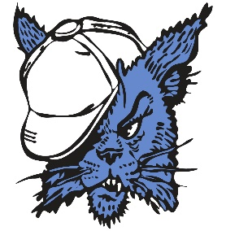

*** Please make sure you enter all athletes on RunnerCard before 7:30 pm on Wednesday, September 2nd. ***
2:00 - Course opens for walk through and warm-up
3:30 - 6th & 7th Girls Race
4:00 - 6th & 7th Boys Race
4:30 - 8th Girls Race
5:00 - 8th Boys Race
***As soon as one race finishes, the next race will begin. Races may run ahead of schedule.***
Ice, Water, and Popsicles: Athletes will have access to ice, water, and popsicles near the finish line.
Stickers: We will be using stickers at the finish line for placing. Coaches will receive their stickers in their coaching packet. Please make sure the following information is on each sticker: Student name (first and last), school, and grade level. All stickers must be placed on the chest of the competitors.
Parking: After dropping the athletes off in the back near the tennis courts, busses will need to park across the street (E. Richards St.) on the dirt road. Overflow parking will be available after 4:00 pm in the South Bus Loop located in front of Douglas Middle School.
Course Markings: The majority of the course will be ran on the jogging path along the North Platte River and marked with flags. Standard yellow, red, and blue flags will be used throughout as well. Course judges will be stationed along the course to handle any emergencies. A Gator will lead each race to ensure the runners follow the appropriate route.
Restrooms: Restroom facilities will be available during the meet, and are located behind the first base line of the softball field near the school. Locker rooms will not be available and coaches/athletes are responsible for their team/personal belongings.
Awards: Shirts will be awarded to the top five finishers of each race listed above.
Entry Fee: None.
Results: Results will be available on RunnerCard following the meet.
We look forward to seeing all of you on Thursday the 3rd. If you have any additional questions, please contact the Activities Office at (307)358-9771 or Coach Emily Haught at (307)358-9771.

2015 DMS River Run Cross Country Meet
Course Map

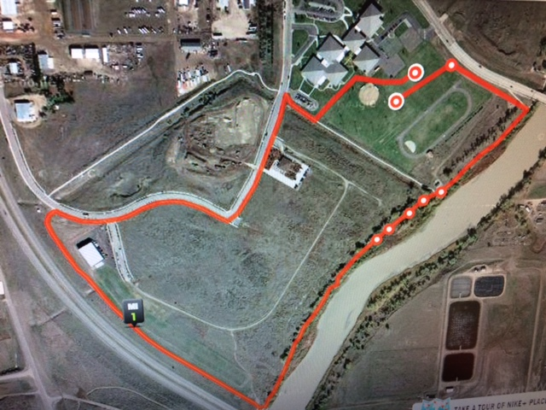

The starting line is the lower bullseye, and the finish line is the upper bullseye.

