
2nd Annual Tiger Trials Invitational

Location: Orem High School
Date: April 28th, 2008
Gender: Male and Female
Each Team allowed: 3 athletes for lane and field events and 4 for distance (800 and up).
Each athlete can compete in 4 events.
Entry Fee: $75.00 per Gender ($150.00 for Boys and Girls).
$8.00 per individuals up to 10 athletes. NO refunds.
Checks to: Orem High School
Registration: www.Runnercard.com

Registration Deadline: REGISTRATION WILL CLOSE. April 26, 2012 at 5:00pm
No late entries or day of meet changes (Please plan ahead)
PLEASE DON’T REGISTER ATHLETES THAT YOU DON’T PLAN ON RUNNING.
PLEASE BE EXACT ON YOUR REGISTRATION. DON’T MAKE DECISIONS AT THE MEET. This will help the meet run smoothly.

Meet Director Contact Information:
Name: Andrew Jacobs
Cell Phone: 801-358-3333
Email: oremcrosscountry@gmail.com

Orem High School
175 Tiger Way
Orem, Utah 84097

- All heats and races will be formed prior to the meet. You will receive a copy of the heat sheets in your coach’s packet.
- All track races will be timed finals with the fastest “Seeded” athletes in the final heat. Field events will be seeded with top athletes competing in final flights.
- All throwing events and long jump will get 3 initial attempts with the top 9 going to finals.
- In its first year, the tiger trials invite established some very good performances.
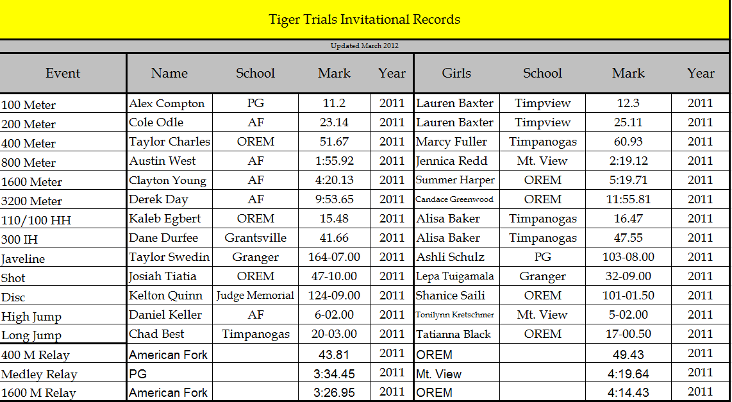

Check into Bullpen 30 min before your event is scheduled to run.

Girls then boys
** All events will go slowest to fastest

7:30 am Weigh Master
8:00 am Coaches Meeting
8:30 am 1600 Meter
100 M Hurdles
110 M Hurdles
100 Meters
4X100 Meter Relay
400 Meters
300 Meter Hurdles
800 Meters
Sprint Medley
200 Meters
3200 Meters
4X400 Meter Relay

Girls then boys
**We will roll the schedule if possible

9:00 am Girls Discus
Boys Shot
Girls Long Jump
Boys High Jump
Boys Javelin

Minimum Marks for Field Events For High School
Shot 27’ Girls
37’ Boys
Discus 75’ Girls
100’ Boys
Javelin 80’ Girls
115’ Boys
Long Jump 13’ Girls
17’ Boys
The crossbars for the High School
High Jump will be raised:
Girls HJ - 4'06", 4'08", 4’09”, 4’11”, 5’00”, 5' 01", 5' 03", 5' 05" one inch thereafter.
Boys HJ - 5' 06", 5’08”, 5' 10" 5' 11", 6' 00", 6’01”, 6' 02" one inch thereafter.

*** We will roll the schedule if possible***
PLEASE LISTEN TO THE ANNOUNCER

