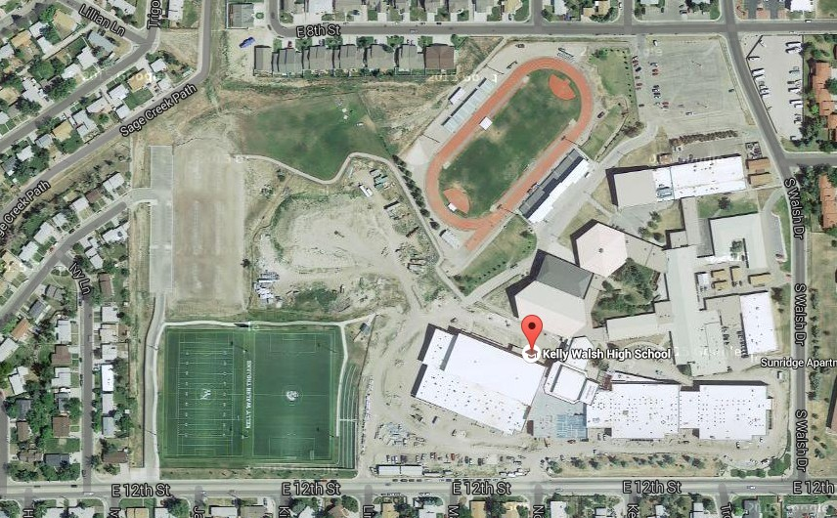

Track Spectator Parking

**Pathway to Track**

**Spectator Parking Area**

**Bus Parking**

**New Bus Parking Area**

**School Main Entry**

.