

Westlake High School Cross Country Classic
September 27th, 2012

Dear Coaches and Athletes
We invite you to the 3rd Annual Westlake High School Cross Country Classic. The event will take place on the fields directly west of the high school and we will also utilize the fields at Vista Heights Middle School. The Course will be all on grass and very flat with next to no hills and will be 3 miles. It is definitely a spikes course.
The cost for this year’s event will be $50 per team or $100 per school. You can either send the money to the school beforehand or bring the check with you. All registration is done on Runnercard.com and Runner Card will also be doing the timing of this year’s event. Registration will close September 26th at noon!
The meet will start at 4:00pm with the JV girls and races will go every 30 minutes. Awards will be handed out after the completion of the Varsity boys’ race. All busses will park in the parking lot directly west of the football stadium.

Where:
Westlake High School
99 North Thunder Blvd.
Saratoga Springs, Utah 84045

When:
September 27th, 2012
JV Girls Race 4:00pm
JV Boys Race 4:30pm
Varsity Girls Race 5:00pm
Varsity Boys Race 5:30pm

Cost:
$50 per team $100 per school
Individual runners will cost $7 each

Registration:
Runnercard.com
Please register by 12:00pm Wednesday September 26th!!!

Awards:
Top 2 varsity teams (boys and girls)
Top 10 individuals in all races

Directions:
From the North:
- Go south on I-15 until the Bangerter Highway exit
- Go west on Bangerter until Redwood Road
- Go south on Redwood Road until you reach 400 North Saratoga Springs (first right after the light at the newly completed Pioneer Crossing)
- The school is on the right and please park in the parking lot directly west of the football stadium.
From the South:
- Go north on I-15 until exit 278 American Fork Main Street/Pioneer Crossing
- Go west on the newly completed Pioneer Crossing until Redwood Road
- Go south on Redwood Road until 400 North Saratoga Springs (this will be the next right)
- The school is on the right and please park in the parking lot directly west of the football stadium.

Course Map:

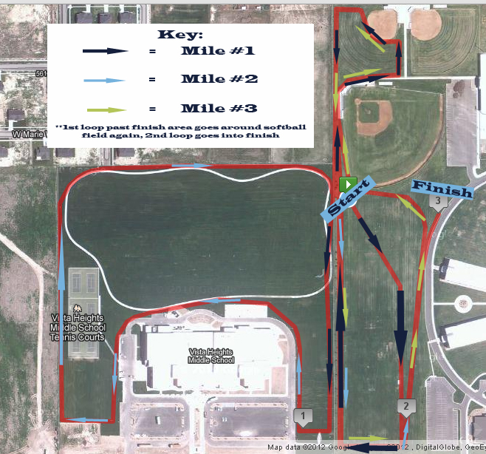

Course Details:
Start:
The race starts at the green “start button” located at the north-west corner of the Westlake practice football field. From there the course goes in a south-east direction diagonal across the field and then directly south down past the school’s soccer field. At the far south end of the field, the course goes west for approx 100 meters and then goes north back towards the starting line.

Middle:
The course then goes and makes a loop past the baseball field and around the softball practice field directly north of the starting line. The course then goes through the gate separating Westlake and Vista Heights and follows the outside perimeter of Vista Heights’ field until it comes back to the gate separating the two facilities. The course then goes left through the gate and around the soccer fields in the opposite direction of the start. Instead of going through the finish chute the course goes west to make one final loop past the baseball field and around the softball practice field.

Finish:
Instead of going through the gate to Vista this time the course goes straight for one more loop around the soccer field and then a straight 200 meter downhill into the finish. The course is 3.0 miles.

