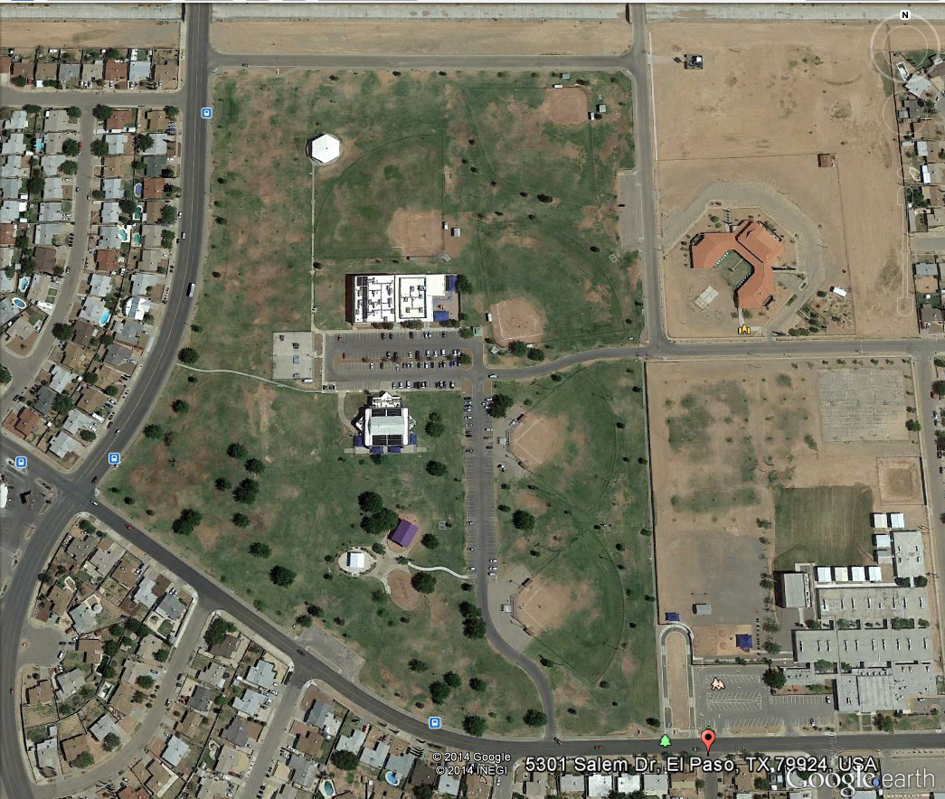
DISTRICT CROSS COUNTRY MEET
VETERANS PARK

COURSE:

START LINE IS LOCATED CENTER OF THE PARK CLOSE TO SALEM STREET.
GREEN ARROWS INDICATE ROUTE THAT WILL BE COMPLETED ONCE.
YELLOW ARROWS INDICATE PART OF COURSE TO BE COMPLETED TWICE
RED ARROWS INDICATE DIRECTION TO THE FINISH LINE

