Wasatch Relays &
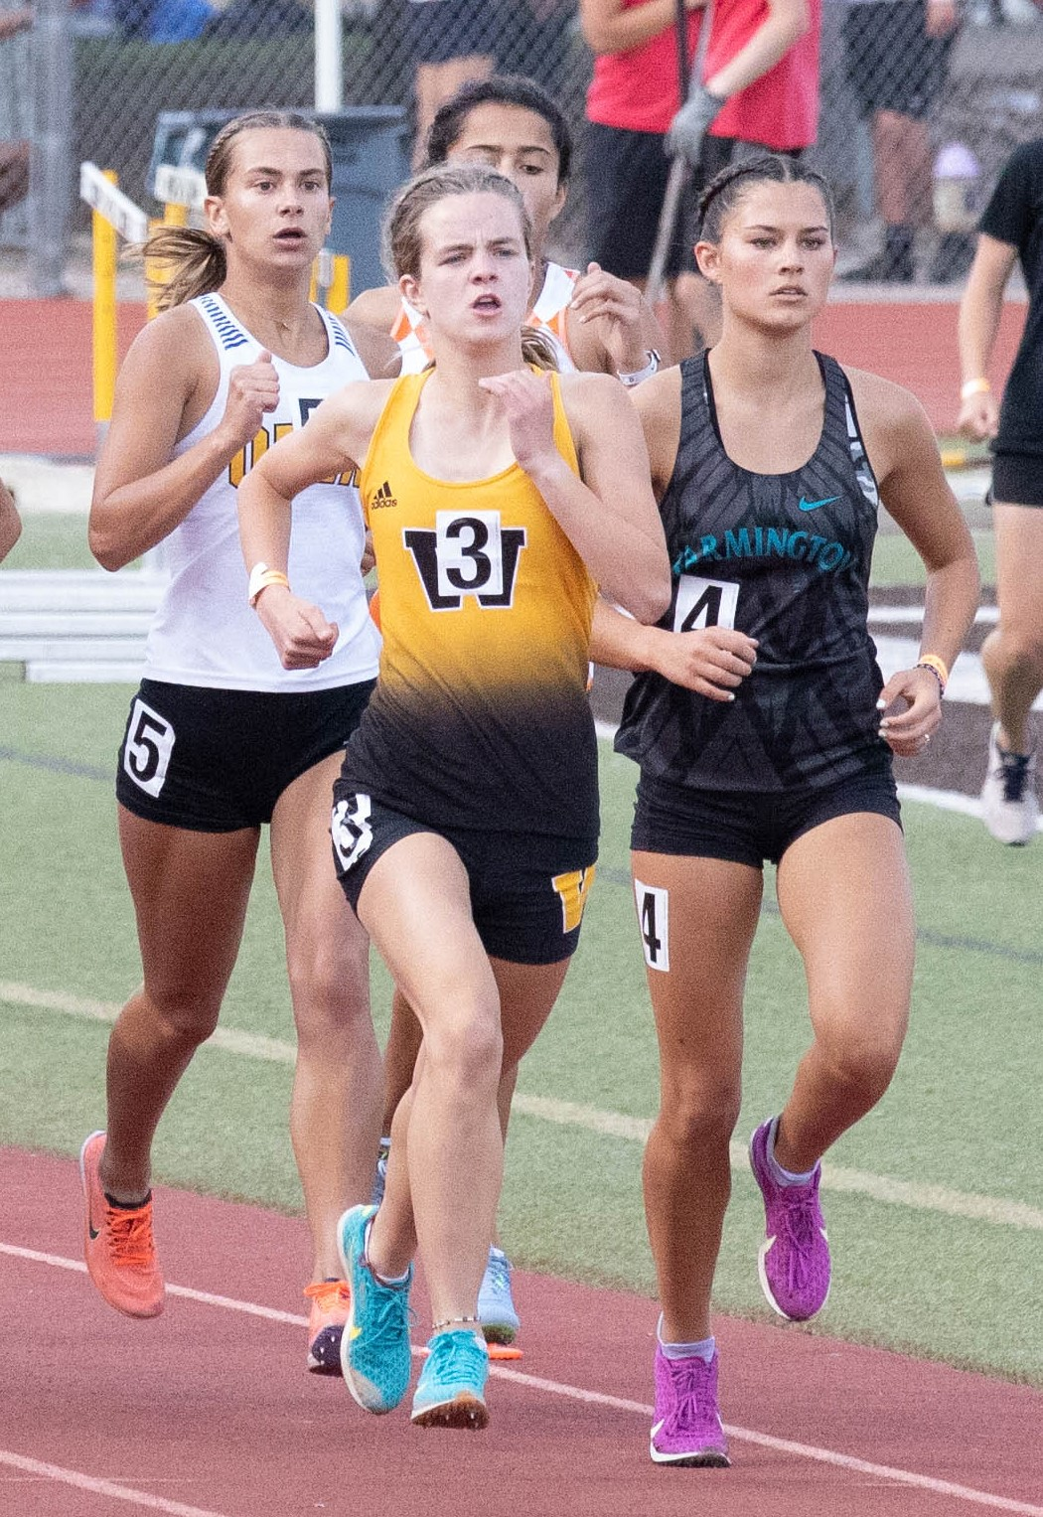
Underclassman
2022 Invitational
If you are like nearly every other program out
there, you have good talent that never sees
the track because they are simply too young.
Here is their chance to shine.
On Tuesday, April 26th, Wasatch High School will host the ninth annual Underclassman Invitational. This IS A STATE qualifying meet, and no athletes other than freshman and sophomores are invited—both boys and girls. (Juniors and/or Seniors that are a 1st year track athlete may participate in the meet). The meet will be evenly paced, and all of our young athletes will be given a chance to experience a high-quality meet with a fully-automatic timing system.
As for now, entries are set at 6—meaning that you may enter up to 6 kids in any event. However, athletes are only allowed to enter up to 4 events total. Additionally, only one relay team will be allowed per school. We will have medals for the top three finishers in each event as well as medals for the top team in each relay. Team cost for the Underclassman is $175 per boys and girls team combined.

The Wasatch Relays section of the meet is for Varsity Athletes. This meet will give you the opportunity to race your varsity athletes in a relay without having to worry about any open races. Each school may enter 2 Varsity Teams per relay. Top 3 teams will medal.
Team cost for the Wasatch Relays is $50 per team (boys & girls) or $25 per relay.

General Meet Information:

The meet will start promptly @ 1:30 pm—see the schedule of events on the following page.

This meet will be run on Wasatch High School’s track and field facility with a fully automatic timing system complete with alphanumeric scoreboard interface--Athletes will be able to see their times on the board as they cross the finish line. There is also a running clock that is visible to all participants

Register on Runnercard.com by Monday, at noon. All heats will be formed at the start of each event and flights for field events will be formed at that site. Please provide the most accurate times (or guesses on times) you can, as well as accurate distances and heights. If no time or mark is entered, the athlete will automatically be placed in a slow heat.

No changes will be made after the deadline has passed, so try to be accurate. Even though
this is an underclassman meet, we want it to run efficiently, and changes to your rosters
complicate that in our system. So, please have everyone entered who wants to run by Monday.

Schedule of events:
Due to time constraints and athlete numbers, we are running a modified schedule—outlined below. Girls will be first in all running events, followed by boys. All events and heats will also be timed finals—so the more accurate time/distance you enter, the more likely your athletes will be to run/throw/jump against the best competition from their relative age group. Please enter the most accurate time you can for each participant so that they have the best chance to improve their time.

Please make sure your athletes have only ¼ inch pyramid spikes. Also, the javelin approach is grass, discus and shot are contested on cement platforms, and jumps are off the rubberized track.

Running Events Field Events Starting at 1:30

3200 Meter Boys Javelin
4 x 800 Meter Relay (Varsity) Girls Shot put
Medley Relay (1A-3A Varsity) Girls High Jump
4 x 200 Meter Relay (Varsity) Boys Discus
100/110 Hurdles Boys Long Jump
100 Meter
400 Meter
4 x 100 Meter Relay (Underclassman) Field Events Starting around 4:30
4 x 100 Meter Relay (Varsity) Girls Javelin
400 Meter Boys Shot put
300 Meter Hurdles Boys High Jump
800 Meter Girls Long Jump
200 Meter Girls Discus
1600 Meter
4 x 400 Meter Relay (Underclassman)
4 x 400 Meter Relay (Varsity)

Please contact me by email if you plan on attending. I need to get a preliminary list together so that I know how many people to plan on—if attendance is too large, I will cut entries so that we can still run the meet on a Tuesday afternoon and not go too late.

For questions contact:
Shauna Bowden
Phone: (435) 671-5944
Email: sb4run@gmail.com

