2021 District 3-5A Cross Country Championships

Date: March 19, 2021
Place of Event: Centennial High School
Starting Time: 4:00 PM
Coaches Meeting: 3:30 PM

Centennial Hawks Cross Country would like to invite you to the 2021 Centennial Hawk Challenge. We appreciate your attendance and competitive spirit and hope to provide you with a pleasurable and safe meet experience this year. Please pay special attention to designated times and meet guidelines. Failure to obey guidelines will result in automatic disqualification of athletes and/or teams.

Thank you,

Coach Epperson
Cell#: 575-642-2370 Email: Anthony.d.epperson@gmail.com or aepperson@lcps.net

Meet/Course Description:
Each school may travel to Centennial with a total of 5 Varsity Boys and 5 Varsity Girls to compete as well as 7 Open Division Boys and 7 Open Division Girls.
The course consists of some grass, dirt, sand, and finishes on the track.
Start Times:
Boys Varsity: 4:00 pm
Girls Varsity: 4:45 pm
Combined Open: 5:30 pm

Team Arrival and Verification:
Please plan accordingly to not arrive too early at the venue. The soonest an athlete will be able to access the competition area is 30 minutes before the scheduled race.
Remember, there are no team camps. Athletes must remain on their bus unless they are using the facilities or warming up for their race. There are no packets to pick up.

Las Cruces High School, Mayfield High School, and Onate High School will park in the South Parking Lot of Centennial High School. Athletes will check in with their Head Coach and be moved to their designated warm-up area by an LCPS administrator.

Schools traveling by bus (Alamogordo, Deming, Gadsden) will enter the Bus Parking Entrance (North) of Centennial High School. An LCPS Administrator will meet you upon arrival and escort your team to their designated warm-up area.

Facilities:
Race officials will alert staff to when teams can go to the warm up area. Athletes will not have a chance to preview the course. Please review the map carefully and let us know if you have any questions.
Designated Warm-up Area:
Area 1 (North Soccer field) – Alamogordo
Area 2 (South Soccer field) – Deming
Area 3 (Basketball Courts) - Gadsden
Area 4 (Softball field) – Onate, Las Cruces
Area 5 (Baseball field) – Centennial, Mayfield

Restrooms: The bathrooms are located near each designated warmup area. Only one athlete at a time will be permitted into the bathroom. There will be a security guard present to ensure that social distancing is maintained and masks are worn at all time. Facilities will be sanitized between each use.
Bathroom Area 1 – Alamogordo
Bathroom Area 2 – Deming/Gadsden
Bathroom Area 3 – Onate, Las Cruces
Bathroom Area 4 – Centennial, Mayfield

Meet Requirements/Scoring/Timing: Sign up at http://runnercard.com You may have to set up an account if you do not have one. It is free. If you have any questions, feel free to contact me. Please include all potential runners to limit changes the day of the race. Entries are due by March 17, 2021 @ 10:00 PM. We will not use bib numbers or finish cards. Each runner will be assigned a number. Coaches are responsible to write their athletes number in Black Sharpie on BOTH hands and left shoulder at least 1 inch tall. They will be recorded at the finish upon completion of their race. Rosters with assigned numbers will be sent to coaches Monday morning.

Starting Line: Please tell your runners to report to the starting line no more than 30 minutes before their assigned race and not later than 10 minutes. Team boxes will be at least 6 ft
wide. There will also be 6 ft between each team box. There should be no runners in this space between. The goal is to keep 6 ft of distance between each runner.

During Race: Please encourage your runners to keep distance between themselves and other runners during the race as much as possible. The beginning of each race will be the most
difficult to keep distance but should be possible during most of the race. Remember, masks need to be worn at all times before, during, and after competition by all coaches and athletes.

Race Completion: There will be not be a finish chute. Runners will cross the line and be guided towards the recovery area. Water will be available for runners. They will walk by, get a bottle of water, and continue to exit the competition area.

Awards:
Top ten individual runners (overall time) in Varsity Divisions will be declared All-District runners and receive medals.
Overall Varsity Champions will receive District 3-5A Cross Country Championship banners.
Top ten individual runners (overall time) in Open Divisions will receive medals. There will be no team awards for the Open Division.

NOTE: There will be no awards ceremony at the District Championships. All awards will be packaged by team and given to the teams Head Coach.

Spectators: There are to be no spectators on campus, however, spectators may watch the race from off campus locations.
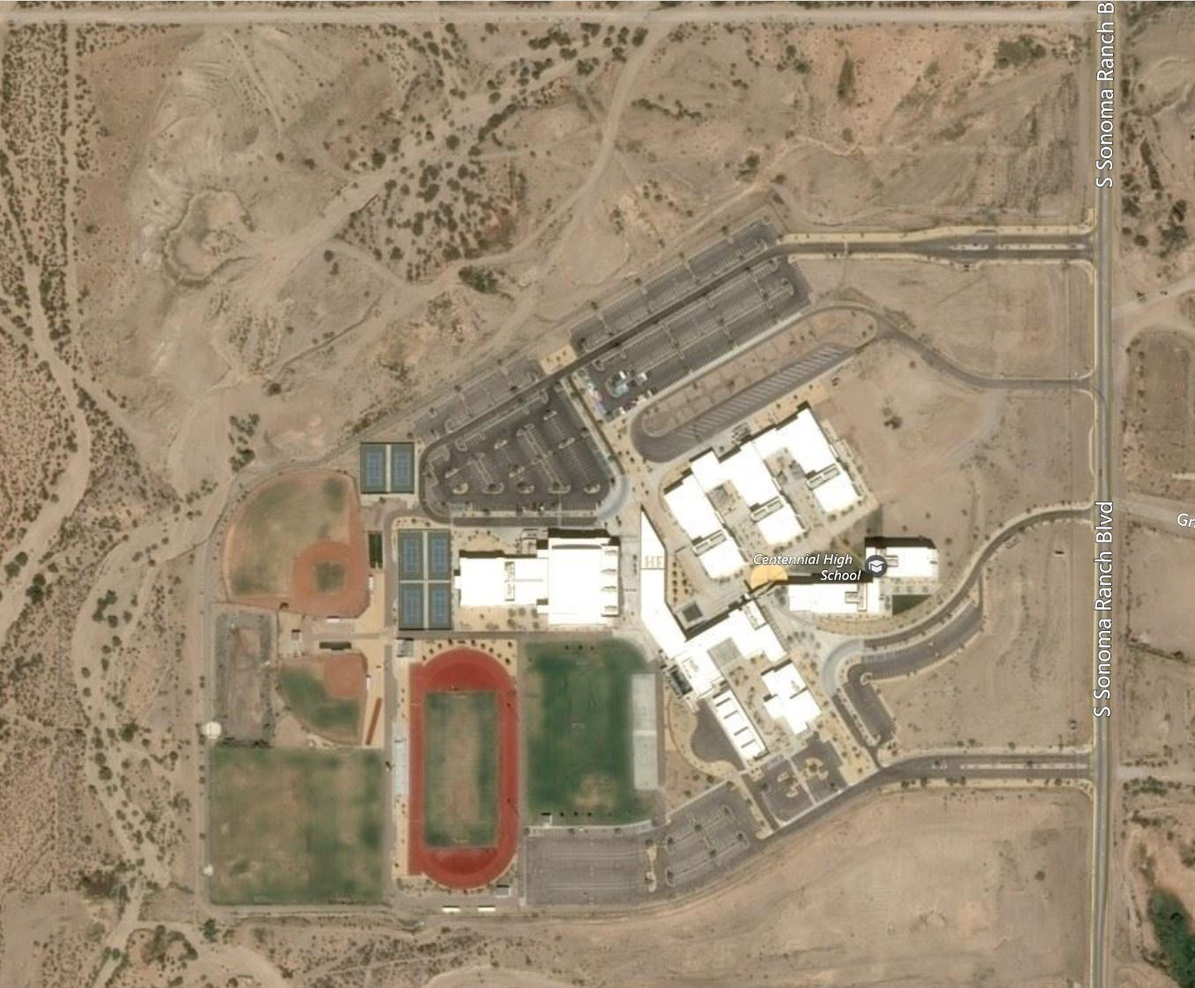
2021 District 3-5A Cross Country Championships Map
1 Mile
2 Mile
Finish
Gates
Bus Parking
AHS/DHS
Centennial Parking
LCHS/MHS/OHS
Parking
Designated
Warm-up Area 1
Designated
Warm-up Area 5
Designated
Warm-up Area 4
Designated
Warm-up Area 2

Restrooms
Restrooms
Restrooms
Restrooms
Designated
Warm-up Area 3
Restrooms
Restrooms
Restrooms
Restrooms

