Berry Bryant/Kyle Johnson Cross Country Invitational

Date: Thursday, October 3, 2019

Site: 1838 Riverton Rendezvous

Location: 1838 Rendezvous Site, S Smith Rd, Riverton, WY 82501, Riverton, WY 82501
(Google map attached)

Starting Times: 1:00 pm Course Inspection
Middle School- 3:00 PM
Girls Varsity- 4:15 PM Boys Varsity- 4:45 PM
Girls Junior Varsity-5:15 PM Boys Junior Varsity- 5:45 PM

- RHS seniors will be recognized before the High school awards

The course is located on a Historical site: Please remind your athletes and fans respect all structures and Markers associated with the Rendezvous site.

- Entries:
Enter all runners for all High School at www.runnercard.com just click on by Berry Bryant by Wednesday we will shut this down at noon on Wednesday. Changes after this time can be made at check in on Friday.

- The varsity teams will be permitted to enter a maximum of seven (7) and a minimum of five (5) for team honors. Junior Varsity & Middle School competition will be unlimited.
- If a course disqualification occurs, the first team finishers will be disqualified if the offending runner cannot be identified by bib #.
- We will be using electronic Timing system. Each runner will issued a Bid # with a timing chip attached. Runner will turn bib #s in at the end of the Finish chute. Any Bib #s not used need to be turned in by the coach before leaving the course.
- Please instruct your runners that upon crossing the finish line to proceed down the chute to the official scoring table and turn in bib #s
- To facilitate prompt scoring, the junior varsity races, which will not be team scored, and will run last.
- Awards will be presented at the conclusion of the junior varsity race. Medals will be awarded to the top ten (10) Varsity boys and the top ten (10) Varsity girls. Top (10) junior varsity will receive ribbons.
- Middle School Awards will be presented at the conclusion of the Middle School race. Medals will be awarded to top (10) 7th/8th Boys/Girls.
- We will have water at the finish line. Please ask your athletes to keep the area neat and clean.
- It is the responsibility of each runner to know the course.
- Middle School Unlimited entries.
- The course will be marked with flags, cones and paint.
- Yellow flags – right turn
- Red Flags – left turn
- Blue Flags – run on either side – straight
- If a flag is not visible, the runner is to follow the painted arrows; run between the cones
- There will be Porta Potties available, there will be no locker room available at the course.

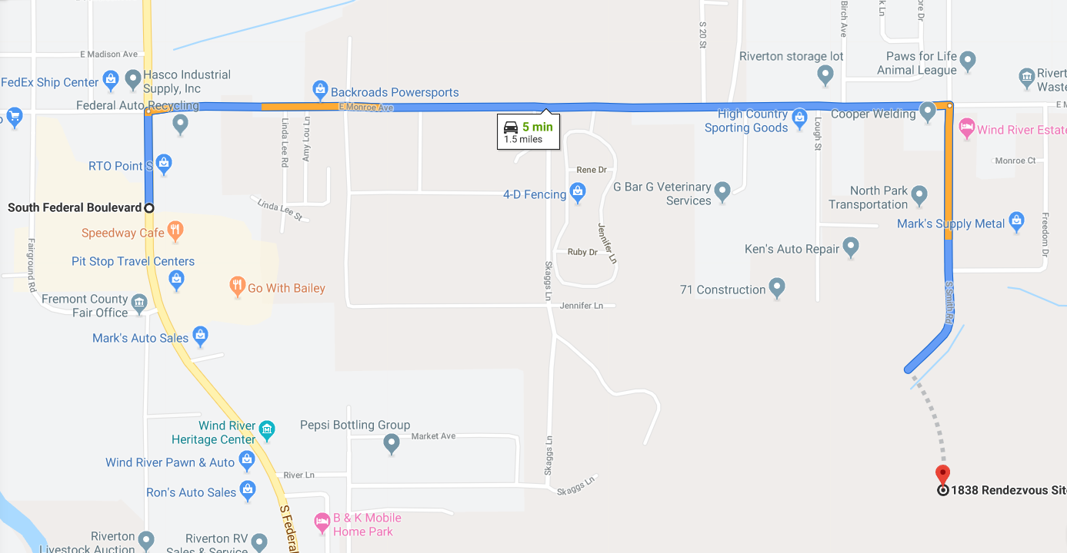

- It will be a two lap race for the 5k High School and one lap for middle schoolers.

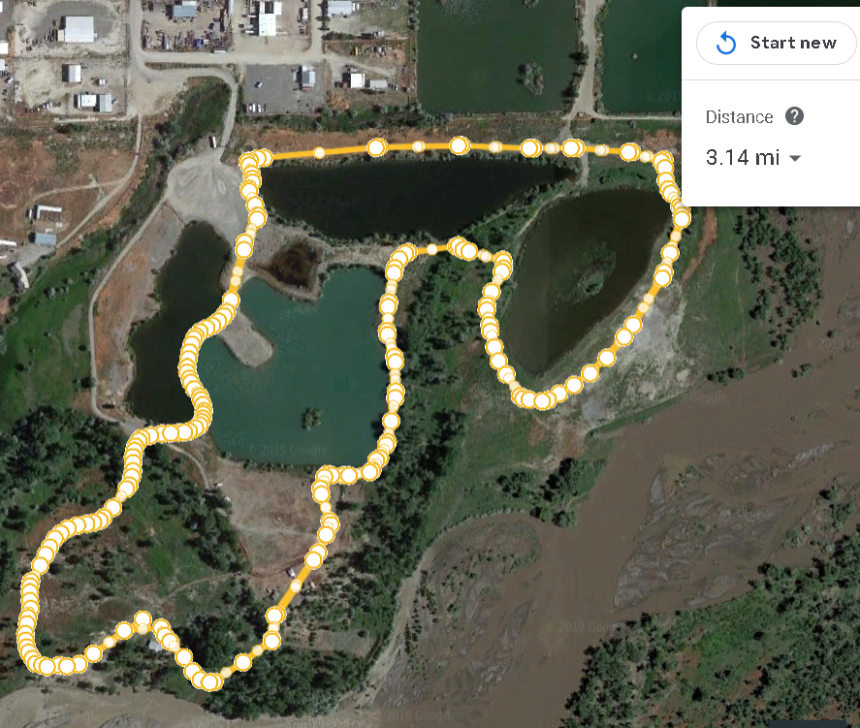
This will be a two lap course.
Strat and finish will be located near the gazebo.
The course is grass, gravel and dirt following both double and single track tails.
Parking Lot
Start and finish

