Berry Bryant/Kyle Johnson Cross Country Invitational

Date: Thursday, September 9, 2021

Site: 1838 Riverton Rendezvous

Location: 1838 Rendezvous Site, S Smith Rd, Riverton, WY 82501, Riverton, WY 82501
(Google map attached)

Starting Times: Middle School Inspection 1:00pm
Middle School Races - 2:00 pm
6,7,8 Girls – 2:00pm
6,7,8 Boys – 2:30pm

High School Course Inspection 3:00pm
High School Races - 4:00 pm
Girls JV & Varsity- 4:00 PM followed by
Boys JV & Varsity- 4:30 PM

5:00 PM. RHS Seniors will be recognized.

The course is located on a Historical site: Please remind your athletes and fans to respect all Structures and Markers associated with the Rendezvous site.

- Entries:
Enter all runners for High School at www.runnercard.com just click on Berry Bryant/Kyle Johnson by Tuesday 9/7/2021 we will shut this down at noon on Tuesday. Scratches or necessary changes may be made at team check in on Thursday.

- The varsity teams will be permitted to enter a maximum of seven (7) and a minimum of five (5) for team honors. Junior Varsity competition will be unlimited.
- If a course disqualification occurs, the athlete will be identified by bib # and reported to the athlete and coach.
- We will be using Electronic Timing system. Each runner will issued a Bib # with a timing chip attached. Runners will turn bibs into Their Coaches and Returned to the Finish line before leaving the course. Any Bibs not used need to be turned in by the coach before leaving the course.
- Please instruct your runners that upon crossing the finish line to proceed directly back to assigned Team Camp and turn bibs into their coaches.
- We will have water at the finish line. Please ask your athletes to keep the area neat and clean.
- It is the responsibility of each runner to know the course.
- The course will be marked with flags, cones and paint.
- Yellow flags – right turn
- Red Flags – left turn
- Blue Flags – run on either side – straight
- If a flag is not visible, the runner is to follow the painted arrows; run between the cones
- There will be Porta Potties available; no locker rooms available at the course.

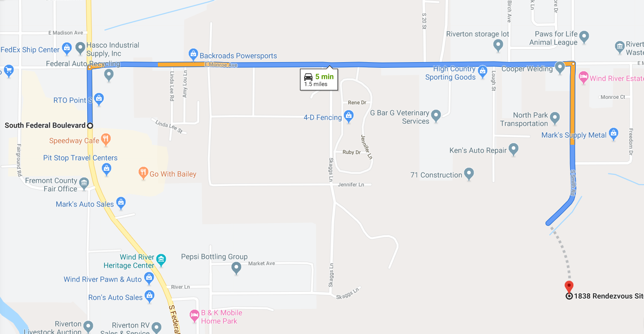
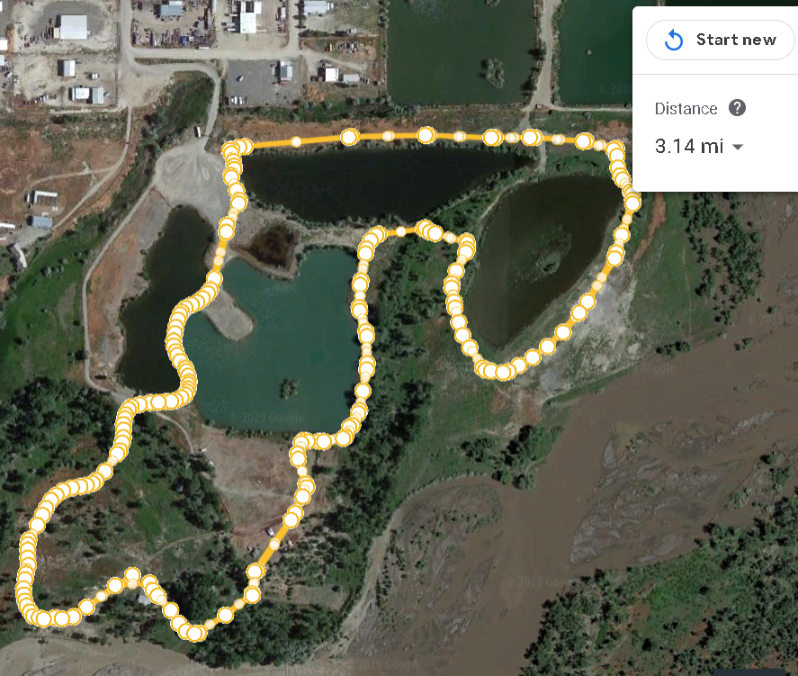
This will be a two lap course.
Start and finish will be located near the gazeebo.
The course is grass, gravel and dirt following both double and single track tails.
Parking Lot
Start and finish
Team Camp
E
Team Camp
D
Team Camp
A
Team Camp
B
Team Camp
C

