2019 Mayfield XC Meet

Date: October 5, 2019
Place of Event: Mayfield High School
School Address: 1955 North Valley Dr. Las Cruces, NM 88007
Start Time: 9:00 AM
Coaches Meeting: 8:30 AM (location will be identified at event).

Mayfield Cross Country would like to welcome you to the 2019 Mayfield XC Meet. We appreciate your attendance and hope to provide you with a pleasant meet experience.

Please enter our campus at the main entrance off of Valley Drive. Bus drop-off will be on the west side of our student/fan parking lots. After drop-off, bus parking will be available in the South parking lot South of Bruins Lane (see maps).

Thank you,
Coach Jereme Santistevan
Home#: 505-929-3147 Email: jereme.santistevan@gmail.com

Course Description: The course consists of some grass, dirt, pavement, gravel, and the finish on the track.

Divisions:
9:00 AM start-- after that, a rolling schedule
Boys Varsity (7 limited)
Girls Varsity (7 limited)
Open Boys (unlimited)
Open Girls (Unlimited)

Awards:
Top ten individual runners in Varsity Divisions will receive medals.

Varsity Team Champions and Runner-up will receive trophies.

Open Division: Top 3-runners will receive medals.

NOTE: All individual medals will be given at the finish line at the end of the chute. In addition, once a division has been scored, team scores will be posted and the coaches will be given their teams trophy.

Meet Requirements: You need to sign up at http://runnercard.com You may have to set up an account if you do not have one, this is free. If you have any questions, feel free to contact me.

Please include all potential runners to limit changes the day of the race. Entries are due by October 3, 2019 by 9:00 PM. We will be using BOTH a card system and the HYTEK software for the meet. You will be given bar codes for each of your runners to put on their cards after the races. PLEASE make sure you or your runners turn their cards into the scores table after the race in a timely manner: failure to do so will result in disqualification of your runner or team.

Mayfield Course Map 2019:
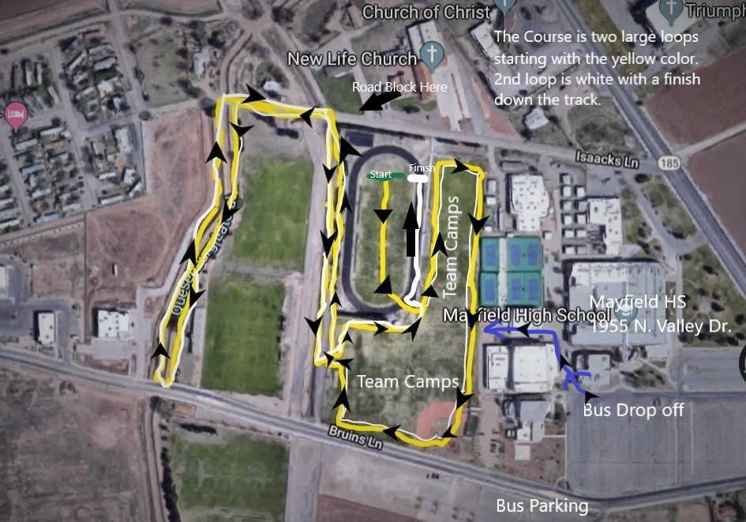

Mayfield Parking Lots: 