Friday, April 30 th

Running Events

6:00 p.m. Girls’ 100-meter prelims
6:10 p.m. Boys’ 100-meter prelims
6:25 p.m. Girls’ 300- meter Hurdles
6:40 p.m. Boys’ 300- meter Hurdles
6:55 p.m. Girls’ 2000 Steeple Chase
7:05 p.m. Boys’ 2000 Steeple Chase
7:15 p.m. Girls’ 200 meters (timed Finals)
7:25 p.m. Boys’ 200 meters (timed Finals)
7:35 p.m. 6th grade girls’ 1600 meters
7:43 p.m. 6th Grade boys’ 1600 meters
7:51 p.m. 7th & 8th grade girls’ 1600 meters
8:00 p.m. 7th & 8th grade boys’ 1600 meters
8:08 p.m. Girls’ 1600 meters
8:15 p.m. Boys’ 1600 meters

Field Events

5:30 p.m. H.S. Boys’ Triple Jump
H.S. Girls’ Long Jump
H.S. Boys’ Shot Put
H.S. Girls’ Discus
H.S. Girls’ & Boys’ High Jump
H.S. Girls Pole Vault

Saturday, May 1st

Field Events

9:00am 7th & 8th Grade Girls Pole vault
6th, 7th & 8th Boy;s and Girls’ High Jump
6th, 7th & 8th Boys’ Shot Put
6th, 7th & 8th Girls’ Triple Jump
6th, 7th & 8th Boys’ Long Jump
6th, 7th & 8th Girls’ Discus
10:30am 6th, 7th & 8th Girls’ Shot Put
6th, 7th & 8th Boys’ Discus
6th, 7th & 8th Boys’ Triple Jump
6th, 7th & 8th Girls’ Long Jump
12:45pm Boys’ Long Jump
Girls’ Triple Jump
Boys’ Discus
Girls’ Shot Put
Boys’ Pole Vault
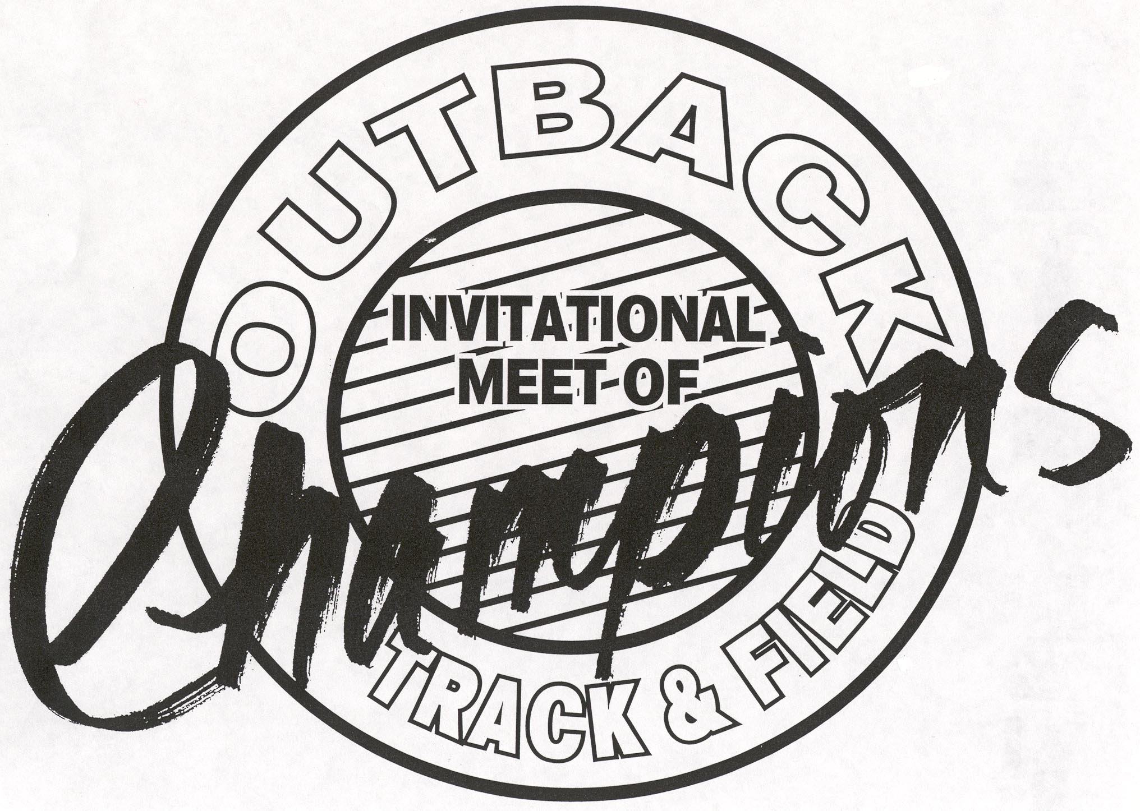

Running Events

10:00 a.m. Girls’ 3200 meters
10:15 a.m. Boys’ 3200 meters
10:27 a.m. 6th grade girls’ medley
10:30 a.m. 7th & 8th grade girls’ medley
10:33 a.m. 6th grade boys’ medley
10:38 a.m. 7th & 8th grade boys’ medley
10:43 a.m. Girls’ 4 x 800m Relay
10:55 a.m. Boys’ 4 x 800m Relay
11:05 a.m. 6th grade girls 100 meters
11:10 a.m. 6th grade boys’ 100 meters
11:15 a.m. 7th & 8th girls’ 100 meters
11:20 a.m. 7th & 8th boys’ 100 meters
11:25 a.m. Girls’ Finals in the 100 meters
11:30 a.m. Boys’ Finals in the 100 meters
11:45 p.m. 6th Grade girls’ 100 m hurdles
11:48 p.m. 7th & 8th grade girls’ 100 m hurdles
11:51 p.m. 6th grade boys’ 100 m hurdles
11:55 p.m. 7th & 8th grade boys’ 100 m hurdles
12:00 p.m. Girls’ 100 Meter Hurdles
12:08 p.m. Boys’ 110 Meter Hurdles
12:10 p.m. 6th grade girls’ 800 M
12:15 p.m. 7th & 8th grade girls’ 800 M
12:20 p.m. 6th grade boys’ 800 M
12:25 p.m. 7th & 8th grade boys’ 800 M
12:30 p.m. Girls’ 800 M.
12:30p.m. Boys’ 800 M
12:36 p.m. 6th, 7th, 8th grade Girls’ 4 x 100
12:40 p.m. 6th, 7th, 8th grade Boys’ 4 x 100
12:45 p.m. Girls’ 4 x 100m Relay
12:48 p.m. Boys’ 4 x 100m Relay
12:55 p.m. 6th, 7th, 8th grade girls’ 200 H
1:05 p.m. 6th, 7th, 8th grade boys’ 200 H
1:15 p.m. 6th girls’ 400 Meters
1:17 p.m. 7th & 8th grade girls’ 400 Meter
1:19 p.m. 6th grade boys’ 400 Meters
1:21 p.m. 7th & 8th grade boys’ 400 Meters
1:23 p.m. Girls’ 400 Meter
1:27 p.m. Boys’ 400 Meters
1:31 p.m. 6th 7th, 8th grade girls’ 200 meters
1:38 p.m. 6th, 7th, 8th grade boys’ 200 meters
1:51 p.m. 6th, 7th, 8th grade girls’ 4 x 400 M
2:06 p.m. 6th, 7th, 8th, grade boys’ 4 x 400
2:21 p.m. Girls’ 4 x 400 Meters
2:35 p.m. Boys’ 4 x 400 Meters

