Friday, April 29th

Field Events

5:30 p.m. H.S. Boys’ Triple Jump
H.S. Girls’ Long Jump
H.S. Boys’ Shot Put
H.S. Girls’ Discus
H.S. Girls’ & Boys’ High Jump
H.S. Girls Pole Vault

Running Events

6:00 p.m. Girls’ 100 meter prelims
6:10 p.m. Boys’ 100 meter prelims
6:25 p.m. Girls’ 300 meter Hurdles
6:40 p.m. Boys’ 300 meter Hurdles
6:55 p.m. Girls’ 2000 Steeple Chase
7:05 p.m. Boys’ 2000 Steeple Chase
7:15 p.m. Girls’ 200 meters (timed Finals)
7:25 p.m. Boys’ 200 meters (timed Finals)
7:35 p.m. 6th grade girls’ 1600 meters
7:43 p.m. 6th Grade boys’ 1600 meters
7:51 p.m. 7th & 8th grade girls’ 1600 meters
8:00 p.m. 7th & 8th grade boys’ 1600 meters
8:08 p.m. Girls’ 1600 meters
8:15 p.m. Boys’ 1600 meters

Saturday, April 30th

Field Events

9:00a.m. 7th & 8th Grade Girls Pole vault
6th, 7th & 8th Boy’s and Girls’ High Jump
6th, 7th & 8th Boys’ Shot Put
6th, 7th & 8th Girls’ Triple Jump
6th, 7th & 8th Boys’ Long Jump
6th, 7th & 8th Girls’ Discus
10:30a.m. 6th, 7th & 8th Girls’ Shot Put
6th, 7th & 8th Boys’ Discus
6th, 7th & 8th Boys’ Triple Jump
6th, 7th & 8th Girls’ Long Jump
12:45p.m. Boys’ Long Jump
Girls’ Triple Jump
Boys’ Discus
Girls’ Shot Put
Boys’ Pole Vault
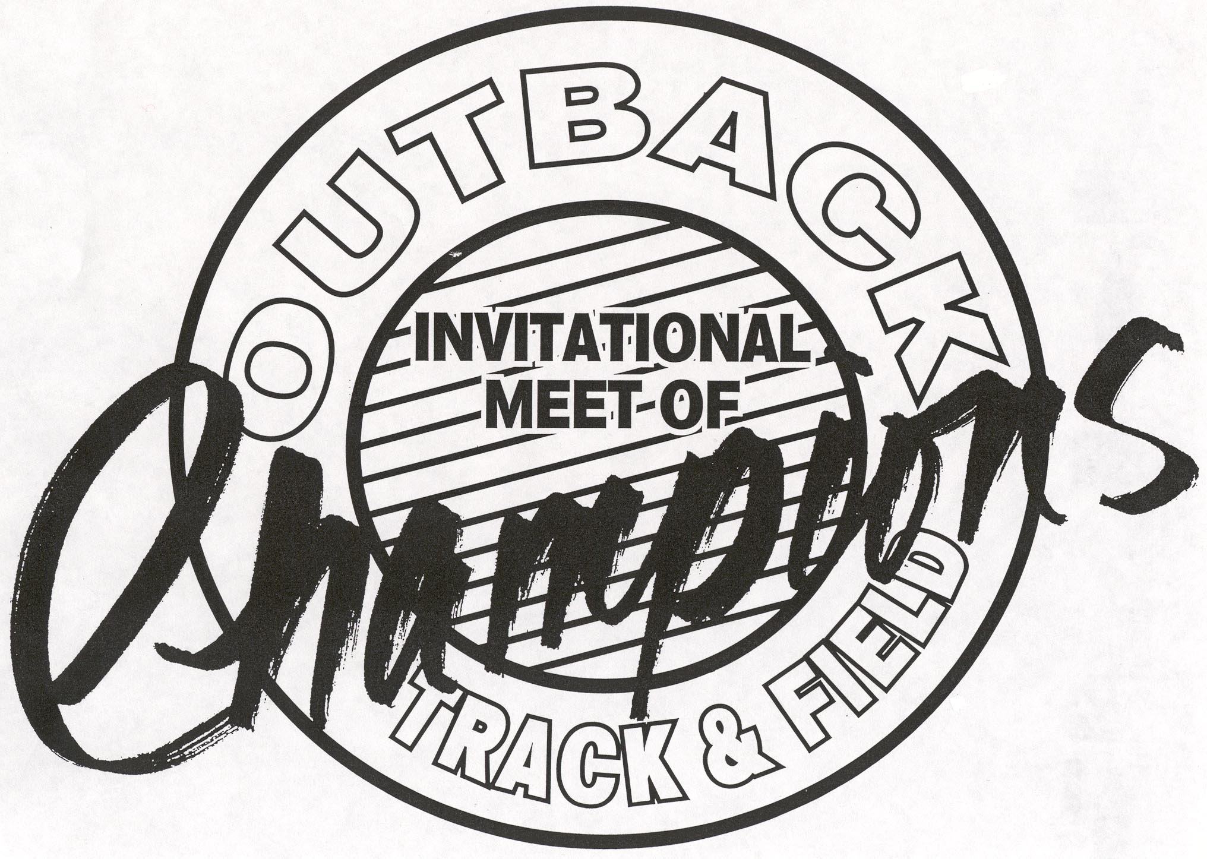

Running Events

10:00 a.m. Girls’ 3200 meters
10:15 a.m. Boys’ 3200 meters
10:27 a.m. 6th grade girls’ medley relay
10:30 a.m. 7th & 8th grade girls’ medley relay
10:33 a.m. 6th grade boys’ medley relay
10:38 a.m. 7th & 8th grade boys’ medley relay
10:43 a.m. Girls’ 4 x 800 meter relay
10:55 a.m. Boys’ 4 x 800 meter relay
11:05 a.m. 6th grade girls 100 meters
11:10 a.m. 7th & 8th girls’ 100 meters
11:15 a.m. 6th grade boys’ 100 meters
11:20 a.m. 7th & 8th boys’ 100 meters
11:25 a.m. Girls’ Finals in the 100 meters
11:30 a.m. Boys’ Finals in the 100 meters
11:45 p.m. 6th Grade girls’ 100 m hurdles
11:48 p.m. 7th & 8th grade girls’ 100 m hurdles
11:51 p.m. 6th grade boys’ 100 m hurdles
11:55 p.m. 7th, 8th grade boys’ 100 m hurdles
12:00 p.m. Girls’ 100 meter Hurdles
12:08 p.m. Boys’ 110 meter Hurdles
12:10 p.m. 6th grade girls’ 800 meters
12:15 p.m. 7th & 8th grade girls’ 800 meters
12:20 p.m. 6th grade boys’ 800 meters
12:25 p.m. 7th & 8th grade boys’ 800 meters
12:30 p.m. Girls’ 800 meters
12:30p.m. Boys’ 800 meters
12:36 p.m. 6th, 7th, 8th grade Girls’ 4 x 100
12:40 p.m. 6th, 7th, 8th grade Boys’ 4 x 100
12:45 p.m. Girls’ 4 x 100 meter relay
12:48 p.m. Boys’ 4 x 100 meter relay
12:55 p.m. 6th, 7th, 8th grade girls’ 200 H
1:05 p.m. 6th, 7th, 8th grade boys’ 200 H
1:15 p.m. 6th girls’ 400 meters
1:17 p.m. 7th & 8th grade girls’ 400 meters
1:19 p.m. 6th grade boys’ 400 meters
1:21 p.m. 7th & 8th grade boys’ 400 meters
1:23 p.m. Girls’ 400 meters
1:27 p.m. Boys’ 400 meters
1:31 p.m. 6th 7th 8th grade girls’ 200 meters
1:38 p.m. 6th 7th 8th grade boys’ 200 meters
1:51 p.m. 6th 7th 8th grade girls’ 4x400 relay
2:06 p.m. 6th 7th 8th grade boys’ 4x400 relay
2:21 p.m. Girls’ 4 x 400 meters
2:35 p.m. Boys’ 4 x 400 meter


Outback Invitational
2005 Qualifying Standards
April 29th & 30th

Girls Standards Provisional

100m 13.3 13.5
100m H 16.8 17.0
200m 27.5 28.0
300m IH 49.6 50.8
400m 62.0 63.0
800m 2:32.0 2:38.0
1600m 5:45.0 5:50.0
3200m 12:30.0 12:40.0
2000 Steeple NO Qualifying time
4 x 100 Relay 53.3 54.0
4 x 400 Relay 4:18.0 4:24.0
Discus 105’ 0” 100’ 0”
High Jump 4' 10” 4’ 08”
Long Jump 15' 6" 15’ 0”
Pole Vault 8' 6” 7’ 6”
Shot Put 33' 0” 32’ 6”
Triple Jump 32' 0" 31’ 0”
Boys Standards Provisional

100m 11.3 11.5
110m HH 16.5 17.0
200m 23.2 23.8
300m IH 43.8 45.8
400m 52.4 53.8
800m 2:05.0 2:08.0
1600m 4:45.0 4:55.0
3200m 10:20.0 10:40.0
2000 Steeple NO Qualifying time
4 x 100 Relay 45.3 46.0
4 x 400 Relay 3:36.0 3:40.0
Discus 130” 120”
High Jump 6' 0" 5’ 10”
Long Jump 20’ 0” 19’ 0”
Pole Vault 12' 0" 11’ 0”
Shot Put 44’ 0” 42’ 6”
Triple Jump 41' 0" 39’ 0”
- The top 24 individuals with the Best times will be advanced into the meet. Individuals who meet the provisional times will be added if the field is not full. All other entrants will be notified. The distance events of 1600meter & 3200 meter will be filled up to 24 athletes.

- We realize this meet is very early and many of your top athletes may not have reached these times yet. If they are proven returning athletes and are healthy, please call me.

- All Relays will need to qualify with 2005 times only.

OUTBACK MIDDLE SCHOOL CHAMPIONSHIPS
Boise State University Ed Jacoby Track
April 29th & 30th

All 6th, 7th, and 8th Grade Track Athletes who meet the following Standards will qualify for the opportunity to compete in the Outback Invitational. All Athletes are allowed to compete in up to 4 events. Please see attached schedule.

ENTRY FEES: $6.00 PER INDIVIDUAL ATHLETE
With maximum team fee of $72.00

QUALIFYING STANDARDS
 | 6th BOYS | 6th GIRLS | 7th & 8th GIRLS | 7th & 8th BOYS
100M | 14.9 | 17.2 | 14.5 | 13
200M | 31 | 33 | 31.5 | 28
400M | 75 | 75 | 70 | 65
100H 33” |  |  |  | 17
100H 30” | 19 | 22 | 20
110H 33” |  |  |  | 17
200H 30” | 32 | 36 | 36 | 32
800M | 2:55 | 3:15 | 2:50 | 2:45
1600M | 6:15 | 6:30 | 6:15 | 5:45
SHOT | 26’ | 17’ | 21’ | 30’
DISCUS | 70’ | 55’ | 55’ | 80’
LONG JUMP | 12’ | 11’ | 12’ | 13’
HIGH JUMP | 4’ | 3’10” | 4’0 | 4’6”
TRIPLE JUMP | 24’ | 22’ | 25’ | 32’
POLE VAULT |  |  | 6’ | 7’6”

SIZE OF IMPLEMENTS: 6 POUND SHOT FOR ALL 6th Grade Boys & Girls
4K FOR THE 7TH AND 8TH Grade Boys & Girls
1K DISCUS FOR ALL PARTICIPANTS

