District 1-2 AAAA Area Track Meet
Mountain View High School
April 15, 2021

Coaches:
Welcome to the District 1-2 AAAA Area Track Meet!

Please read the following General Information sheet to answer any questions you might have. Please make sure your athletes are listening for announcements about races, lane assignments, etc. and they follow the rules regarding our facilities. If you have any questions, please call us and we will try to answer them for you.

- The District Chairs from each district need to fax/ email the results of their respective district meets on the proper UIL form to Gary Rundell and Michael Mackeben. http://www.uiltexas.org/files/athletics/forms/tf-results.pdf
- FAX 915-855-2503 Email: gary.rundell@clint.net
- FAX 915-926-4029 Email: michael.mackeben@clint.net
- Shot and Disc weigh-in will be held in the weight room at the North end of the football stadium.
- Pole Vault weigh-in will be held in the varsity football locker room of the field house.
- All food and drinks, except water, must stay in the team camps.
- NO SUNFLOWER SEEDS!!!! It is next to impossible to get them off the field turf.
- Parents and non-participants need to be in the stands to keep traffic to a minimum. (Infield is for coaches and warm-up only)
- Team camps will set up in the bleachers on either side.
- Meal provided for all coaches, officials, and workers from 5:00 - 6:00.

We look forward to having you in El Paso.

Gary Rundell Mario Loya Liz Castillo Laura Torres Fernie Reza
A.C./Head Track Pole Vault Coach Hurdles Coach Jumps Coach Distance Coach
(575) 496-7725 (915) 383-6707 (915) 494-2112 (915)-667-9978 (915)-355-8311
District 1-2 AAAA Area Track Meet
April 15, 2021

Schedule of Events

** All running events will be run on the time schedule recommended by the UIL**

** High jump and pole vault will open with the lowest qualifying height**

Shot Put Discus Long Jump Triple Jump High Jump Pole Vault (East Pit) (West Pit)
V- Boys V- Girls V- Boys V- Girls V- Boys V- Girls
V- Girls V- Boys V- Girls V- Boys V- Girls V- Boys

Wheel Chair Shot Put (West Ring)
V-Girls
V-Boys

If your athlete has conflicting field events, have them check in to both events and let the person in charge know they have a conflict. All times are listed as Mountain Standard Time.

12:00 PM 3200 Meter Run
12:00 PM Field Events Round 1
1:00 PM Field Events Round 2
2:00 – 3:00 PM Meal Break

**Running order will be Varsity Girls, Varsity Boys**

3:15 PM 4 x 100 Meter Relay
3:30 PM 800 Meter Run
3:45 PM 100/110 Meter Hurdles
4:00 PM 100 Meter Dash Women, Wheelchair, Men
4:15PM 4 x 200 Meter Relay
4:30 PM 400 Meter Dash Women, Wheelchair, Men
4:45 PM 300 Meter Hurdles
5:00 PM 200 Meter Dash
5:15 PM 1600 Meter Run
5:30 PM 4 x 400 Meter Relay

EVENT ASSIGNMENTS:

Pole Vault: Mountain View, Seminole, Pecos

Triple Jump: Pecos, Clint, Ft. Stockton

Shot Put: Riverside, Monahans, Midland Greenwood

Discus: San Elizario, Andrews, Fabens

High Jump: Midland Greenwood, Seminole, Riverside

Long Jump: Andrews, Fabens, Ft. Stockton

Wheel Chair Shot Put: Mountain View, Monahans

Bolded, underlined school will run the event, assisted by the two schools also listed.

5-3-3 & 4, 5-10-6 thru 11: Clarifies that in the 4x100-meter relay and 4x200-meter relay, and other relays with legs of 200 meters or less, each exchange zone will be 30 meters long. All exchange zones for races in excess of 200 meters will remain at 20 meters.
Rationale: In the 4x100-meter relay and 4x200-meter relay, and other relays with legs of 200 meters or less, each exchange zone will be 30 meters long. All exchange zones for races in excess of 200 meters will remain at 20 meters.

Any visible garment(s) worn underneath the uniform top and/or bottom is considered a foundation garment.
All relay team members must wear uniforms clearly indicating, through predominate color, school logo, and color combination of all outer garments worn as a uniform, which members are from the same team.
Matching requirements on foundation garments above and below the knee are not subject to these restrictions.
The officials should be able to observe that all members are from the same team.

4x100 1st Exchange: Clint, Andrews Exchange Zones: Yellow to Yellow
2nd Exchange: Fabens, Seminole
3rd Exchange: Riverside, Ft. Stockton

4x200 1st/3rd Exchange: San Elizario, Monahans Exchange Zones: 1st/2nd Green to Green 3rd Yellow to Yellow
2nd Exchange: Midland Greenwood, Mountain View

800 Break-In: Pecos

4x400 Relay Break-In: Pecos

4x400 Exchanges: Riverside Exchange Zones: Blue to Blue

Athletic Director Clint ISD: Mike Mackeben
Meet Referee: Pat Aguilar/Gordon Clemens
Meet Director: Gary Rundell
Starter: Dr. Luis Luna
Back-Up Starter: Rick Pinon
Timer/Scoring Maria Barros/Candy Anson
Finish Line Clerk: Jessica Frausto
Athletic Trainers: Connie Sanchez/Eric Rueda
Presentation of Colors: Mountain View ROTC
National Anthem: MVHS Choir
Announcer: DJ Check
Check In Clerk: Mike Ortega
Hurdle Crew: Liz Castillo/MVHS JV Track Team
Implements Weigh In: Coach Resendiz/Riverside High School
Pole Vault Weigh In: Mario Loya

Meet Information:

Parking:
- Buses will enter through East Gate at the end of Greg Drive and park behind the school and on the East side.
- We will have security to help guide you through the gate, where to drop athletes and park.
Security:
- You will need to screen all athletes before they come to the meet. All athletes and coaches will have their temperature checked as you enter the gate.
- If anyone has a temperature over 100 degrees, they will need to be re-screened after 10 minutes. If their temperature is still over 100 degrees, they will have to leave the meet and a coach will have to monitor them.
- FANS will be allowed to enter the meet. They will sit in the fans designated area. (Check Image for details.). Each athlete may designate (2) fans to attend.
- The PASS LIST must be submitted by 10:00 AM MST the day before the meet. No substitutions will be allowed at the gate. Masks are mandatory at all times.
Bathrooms:
- Bathrooms are available by the concession stand and inside the gym area.
Safety:
- There will be several hand sanitation stations around the field to use
- Trash cans will be located on the field – please have your kids clean up their area
- Hand sanitizer stations will be located around the field for your use
- Remind kids that high fives, hugs, jumping on each other, etc. is not allowed and they need to remain 6 feet apart at all times.
Trainers:
- Our trainers will provide water at the finish line
- Please tell your athletes to bring their own water bottles to the meet
- There will be a station for the athletes to refill their bottles as needed
- Please have your athletes taped and treated before they come to the meet. Our trainers will be there to assist any new injury at the meet but not to tape kids before they compete.
Team Areas:
- Each team will have a designated area in the stands and your team must remain in that area when they are not warming up or cooling down.
- Tents will be allowed in the upper half of the stands.
- There will be a designated warm up/cooling down area on the football field. This is the only area that

- they will be allowed to warm up or cool down in.
- Please have your kids remain in the stands when not warming up- NO camps or you will not have any room to warm up
- Please have you runners use the hurdles in the warm-up area only. Please do not move hurdles in or out of that area.
- Each area in the stands will be marked with your team name
- Coaches need to assure their athletes are social distancing in the stands and on the field
- Masks MUST be worn by all coaches and athletes, except when they are competing or warming up.
- NO food or drinks, other than water is allowed on the field at any time
Hospitality:
- Provided in the gym for coaches, bus drivers, and volunteers
Additional Information:
- Trash cans will be located around the field, please have your kids clean up their area
- Please have your kids be aware of flagged area. They need to watch out for jumpers on the runways and high jump area and be careful around the throwing area
- Remind the kids that they can no longer run backwards on the runways (UIL guidelines)
- Athletes using profanity may be disqualified from the event or meet
- Tennis balls, soft small items, and tape are allowed on the track for relays- no rocks
- Kids need to report to their field events to get marks 30 minutes prior to the start of the event
- Athletes will be called from the warm-up area to the running events for check in, please have them listen
- and report on first call- we need to stay on schedule for the afternoon
- Blocks will be provided and located near the start of each race.
- Medals will be given to 1st -3rd/4th

Streaming Link (select the meet button)
https://sites.google.com/clint.net/clint-isd-athletics/home

UIL Meet Entry Form
https://www.uiltexas.org/files/athletics/TF_Entry_Form.pdf
Track & Field Protest Form
https://www.uiltexas.org/files/athletics/State_Tf_Protest_Form.pdf
Relay Card
https://www.uiltexas.org/files/athletics/Relay_Cards_with_Alternates.pdf

COVID – 19 Screening Verification
2020-2021

SCHOOL: ___________________________

SPORT: Track & Field 1-4A Area Meet

This verifies all relevant personnel and athletes have been screened TODAY, as they entered the bus to come to the 1-4A Area Track & Field Meet. No Coach, Personnel, or athlete presented with a temperature over 100 Degrees Fahrenheit upon screening.

COACH: ___________________________________
Printed Name

COACH: ___________________________________
Signature

DATE: ___________________________________

COVID-19 Symptoms

Have you recently begun experiencing any of the following in a way that is not normal?

- Feeling feverish or a measured temperature greater than or equal to 100.0 degrees Fahrenheit
- Loss of taste or smell
- Cough
- Difficulty breathing
- Shortness of breath
- Fatigue
- Headache
- Chills
- Sore throat
- Congestion or runny nose
- Shaking or exaggerated shivering
- Significant muscle pain or ache
- Diarrhea
- Nausea or vomiting
- In the last 14 days, have you been in close contact with a suspected or confirmed case of COVID-19 or tested positive yourself?
Close contact is defined as:
- being directly exposed to infectious secretions (e.g., being coughed on while not wearing a mask or face shield); or
- being within 6 feet for a cumulative duration of 15 minutes throughout the day.

Map of:

Mountain View High School
14964 Greg Drive
El Paso, TX 79938

Visitor Parking/Entry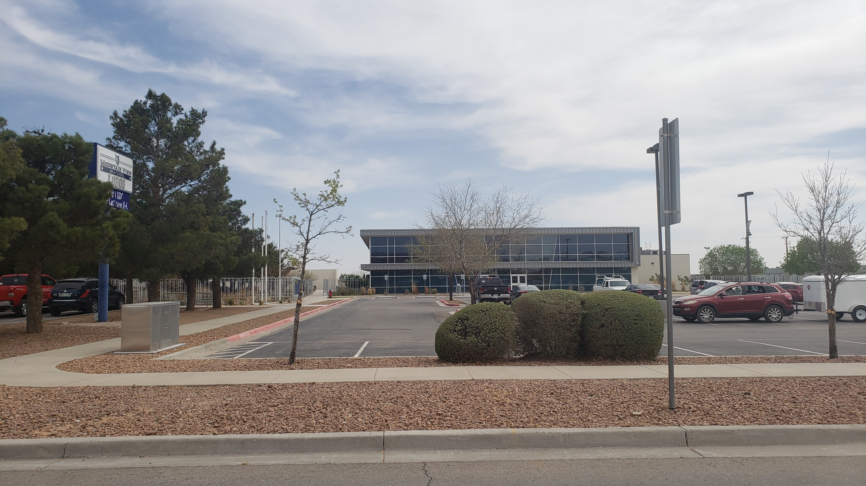

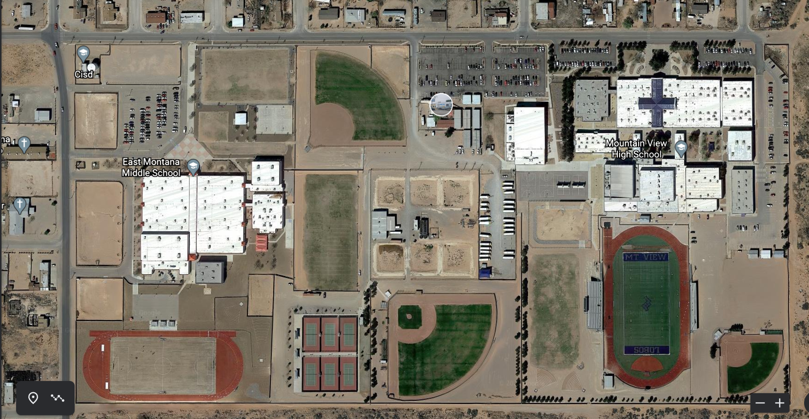
Visitor Entrance
Athlete and Coach Entrance/Screening
AT Station
Shot & Discus
Restrooms, Shot Weigh and Pole Vault Check in
Bus
Parking
Visitor Parking

Field Map:

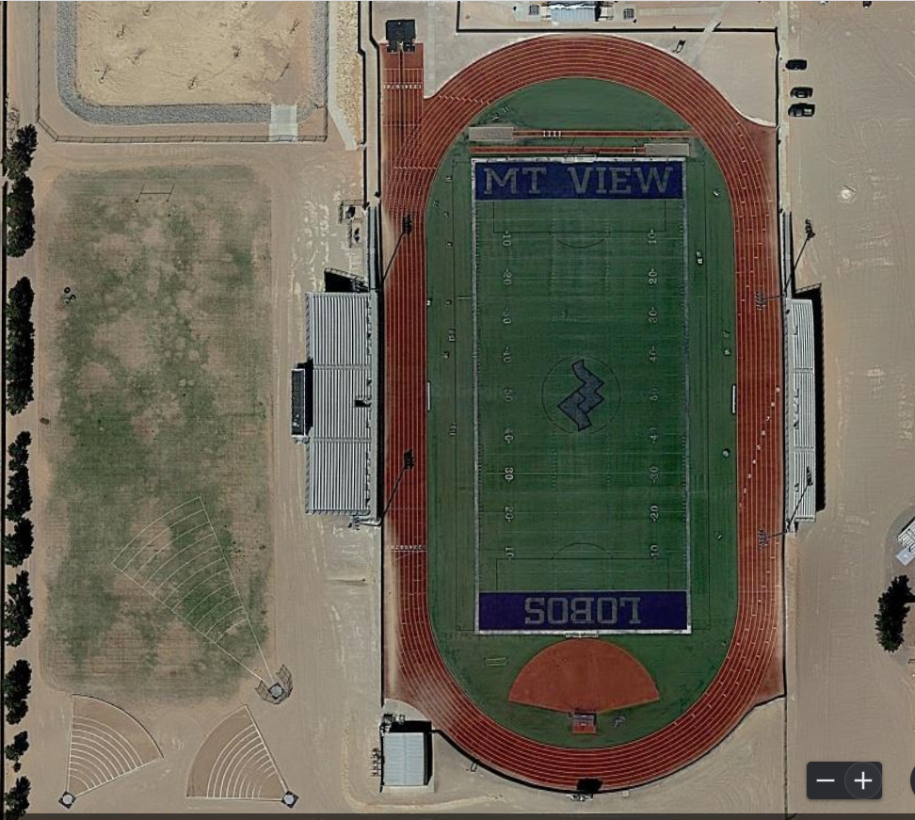
Sanitizer
Sanitizer
Awards
Staging
Check In
Restroomss
Timer Tent
Athletic Trainers
Monahans
Fabens
Clint
Ft Stockton
Greenwood

Andrews
Riverside
Mtn View
San Eli
Pecos
Seminole

Visitors
Visitors

