2017 East Classic – Best of the Best
Qualifying Standards

ALL ENTRIES REQUIRE THE APPROPRIATE MARK. NO MARK – NO COMPETE. Each school gets 2 (two) entries. We ask that each coach keep the qualifying standards in mind when trying to decide whether to enter an athlete. If a school has more than two athletes they want to enter in an event, ALL entries MUST meet the qualifying mark (including the 2 “freebies”). The only exception to the Qualifying Standard is the three relay races. Each school may still only bring one relay team per event/grade/gender just as we have done in the past. The relay teams will not have to qualify either. Do keep in mind that each relay an athlete is on constitutes one of the four-event total in which an athlete may compete. We recommend that each coach use www.athletic.net for their results. This site will track all performances in Wyoming and throughout the United States.

Event | 7 Girls | 8 Girls | 7 Boys | 8 Boys
100 | 14.61 | 14.27 | 13.55 | 12.72
200 | 30.51 | 30.13 | 28.65 | 26.65
400 | 1:10.53 | 1:11.87 | 1:05.34 | 59.68
800 | 2:54.59 | 2:57.36 | 2:38.19 | 2:30.78
1600 | 6:54.78 | 6:36.83 | 6:02.46 | 5:49.37
2400 | 13:02.28 | 11:26.00 | 10:19.90 | 10:25.68
55/75 H | 11.44 | 11.34 | 14.41 | 13.96
100 H | 20.44 | 20.00 | 18.98 | 18.80
200 H | 36.31 | 35.89 | 32.84 | 30.80
SMR | N/A | N/A | N/A | N/A
400 R | N/A | N/A | N/A | N/A
1600 R | N/A | N/A | N/A | N/A
HJ | 4’ 0” | 4’ 2” | 4’ 8” | 5’ 0”
LJ | 12’ 4.75” | 12’ 10.75” | 14’ 4” | 16’ 0.5”
TJ | 27’ 4.75” | 27’ 6.5” | 30’ 2.5” | 33’ 1”
PV | 6’ 0” | 6’ 0” | 7’ 0” | 8’ 0”
S (4K) | 22’ 11.5” | 25’ 8.75” | 30’ 7” | 35’ 10.5”
D | 66’ 5.5” | 75’ 9.5” | 89’ 7.25” | 108’ 5.75”

Athletes may only compete in either the Cross-Country OR the 1600.

We will have a meet official and protest committee this year.

- We are trusting coaches to be honest and ethical. If we suspect this of not being the case, coaches may be questioned and/or asked not to bring teams back to the East Classic. We need your help to keep this a prestigious event.
- Parents are not allowed in the Press Box – all communication with meet officials must come from a coach.

For our more “Mature” coaches….As Paul Harvey used to say: “And now, for the rest of the story….”

“2017 East Classic – Best of the Best”
Bearcat Stadium – Douglas, WY
Monday, May 8th, 2017
10:00 a.m. start
Meet Directors: Chad Johnson (Douglas) – cjohnson@ccsd1.org - 359-8966 (Cell); 358-9771 (School)
Walt Smith (Torrington) – wsmith@goshen1.org – 534-6815 (Cell); 532-7014 (School)
Meet Official:
Protest Committee:
Divisions: 7th Girls; 8th Girls; 7th Boys; 8th Boys (6th Graders must compete in upper grades)
Entries: Will be made on www.runnercard.com . Total number of athletes a school may bring is unlimited. Entries will be limited to 2 per event (unless the qualifying procedure is met) and 1 relay team for each relay (no additional relays). An athlete may compete in up to 4 events total (including relays).
Entry Fee: $5/athlete up to $100/school (20 athletes). This is to help defer some of the costs. Checks/PO made out to Douglas Middle School.
Awards: Medals for 1st, 2nd, 3rd place. Certificates for any meet record. Certificates will be mailed at a later date.
Concessions: Concessions will be available. Provided by a DMS School Club. Please support these students.
Scratch/Add: All Scratch/Adds due on www.runnercard.com by 12:00 pm (noon) SUNDAY, MAY 8, 2106. No further changes after that time, this includes field events on Monday. We will NOT have a scratch/add meeting. All no-shows will be marked DNS.
10:00 a.m. Start of all Field Events & 2400m Run

Participation Rules:
- Two (2) individuals per event, per school in each division, unless qualifying procedure is met.
- One (1) relay per event, per school in each division.
- An athlete cannot compete in both the 7th & 8th grade divisions.
- 6th graders must compete in the upper grade divisions and will count as one of the school’s two entries.
- AN ATHLETE MAY ONLY RUN IN EITHER THE 1600 OR 2400 CROSS-COUNTRY, NOT BOTH. THIS IS TRUE EVEN IF THEY QUALIFY FOR BOTH EVENTS, AND/OR THEY COULD WIN BOTH EVENTS. WE DO NOT FEEL THIS IS IN THE BEST INTEREST OF THE ATHLETE DUE TO THE DISTANCES OF THESE RACES AND THESE RACES BEING RUN SO CLOSE TO EACH OTHER IN THE SCHEDULE.
- Depending on numbers, the 7th & 8th grades might be run together in the 2400m; 1600m; 800m. They will be placed/scored separately. Boys and girls will run separately.
- One-eighths inch (1/8”) spikes only. Please instruct your athletes not to mark the track or runways by scratching with their spikes.
- The 2400m and all field events will start at 10:00 a.m. Events will then follow each other as soon as one is finished. We will not follow a strict time schedule. Please make sure your athletes are prepared to compete at all times.
- Running events take priority over field events. If an athlete needs to leave a field event they must inform the field event judge. Athletes are expected to return to the field event immediately upon finishing their running event.
- Field events flights are shortest to longest seed distance/height. Running events will be heated slowest to fastest seed times. Please provide accurate times/distances/heights.
- All running events are timed finals. There are no prelims.
- Field events will have 3 throws/jumps, no finals.
- Pole Vault – 7th/8th grade will vault together but scored separately. Boys and girls will vault separately.
- All heats will be staged in the starting chutes at the south end of the track.
- Automated timing will be used for this meet.

Special Information – Please be advised of the following:
Hurdles: The 7th/8th grade girls’ hurdle height will be 30” for all distances (55m; 100m; 200m). **Note running order
The 7th/8th grade boys’ hurdle height will be 33” for (75m & 100m) & 30” (200m). **Note running order

Shot Put: We will throw the 4K shot in all divisions. Shot Puts will be weighed and only marked shot puts allowed in the competition. Shot Puts must be declared at the start of the event and kept in the ring area until the division is completed.

Discus: We will throw the 1K discus in all divisions. Discus will be weighed and only marked discus allowed in the competition. Discus must be declared at the start of the event and kept in the ring area until the division is completed.

HJ/PV Starting heights for the High Jump: (7th Girls-4’ 0”); (8th Girls-4’ 2”); (7th Boys-4’ 6”); (8th Boys-4’ 8”)
Starting heights for the Pole Vault: (7th/8th Girls-6’ 0”); (7th/8th Boys-7’ 0”) --- Grades vault together, scored separately.

Order of Events
Field Events – 10:00 start
Once the High Jump/Pole Vault bar is raised it will not be lowered. (If your athlete is in the High Jump/Pole Vault AND other field events, have them ask the field event judge to let them go first in those events. They then need to complete all their throws/jumps first before going to the High Jump/Pole Vault)
Running events take priority over field events. Make sure the athlete tells the field event judge prior to leaving to run. Athletes are expected to return to the field event immediately after completing their running event.

High Jump: 7th Boys - 8th Boys - 7th Girls - 8th Girls ** 2” increase/round
Pole Vault: 7th/8th Girls (Run together, scored separately) – 7th/8th Boys (Run together, scored separately) ** 6” increase/round
Long Jump: 8th Boys - 7th Boys - 8th Girls - 7th Girls (LJ Pit) ** 3 Jumps – No Finals
Triple Jump: 8th Girls - 7th Girls - 8th Boys - 7th Boys (TJ Pit) ** 3 Jumps – No Finals
Shot Put: 7th Girls - 8th Girls - 7th Boys - 8th Boys 4K Shot Puts Only ** 3 Throws – No Finals
Discus: 7th Boys - 8th Boys - 7th Girls - 8th Girls 1K Discus ** 3 Throws – No Finals

Running Events – 10:00 start
All running event will go in this order – 7th Girls; 8th Girls; 7th Boys; 8th Boys unless otherwise noted (see hurdle races). The 2400m will be the first running event with all other running events to follow immediately upon the completion of the previous event. All athletes need to be ready to compete at all times.
- 2400m Cross-Country Run
- 1600m Run
- 100m Hurdles (Girls) – 30”
- 100m Hurdles (Boys) – 33”
- 75m Hurdles (Boys) – 33”
- 55m Hurdles (Girls) – 30”
- 100m Run
- 400m Relay
- 400m Run
- 200m Hurdles (Girls & Boys) – 30”
- 800m Run
- 200m Run
- Sprint Medley Relay (1-1-2-4) – 4x1 exchange zones w/400 cut at start
- 1600m Relay

Coaches will be asked/assigned to help run off field events, set/remove hurdles, and to pick and/or time.
Seeding/Flights will be determined by times/distances/heights entered on RunnerCard. ALL entries require appropriate marks.

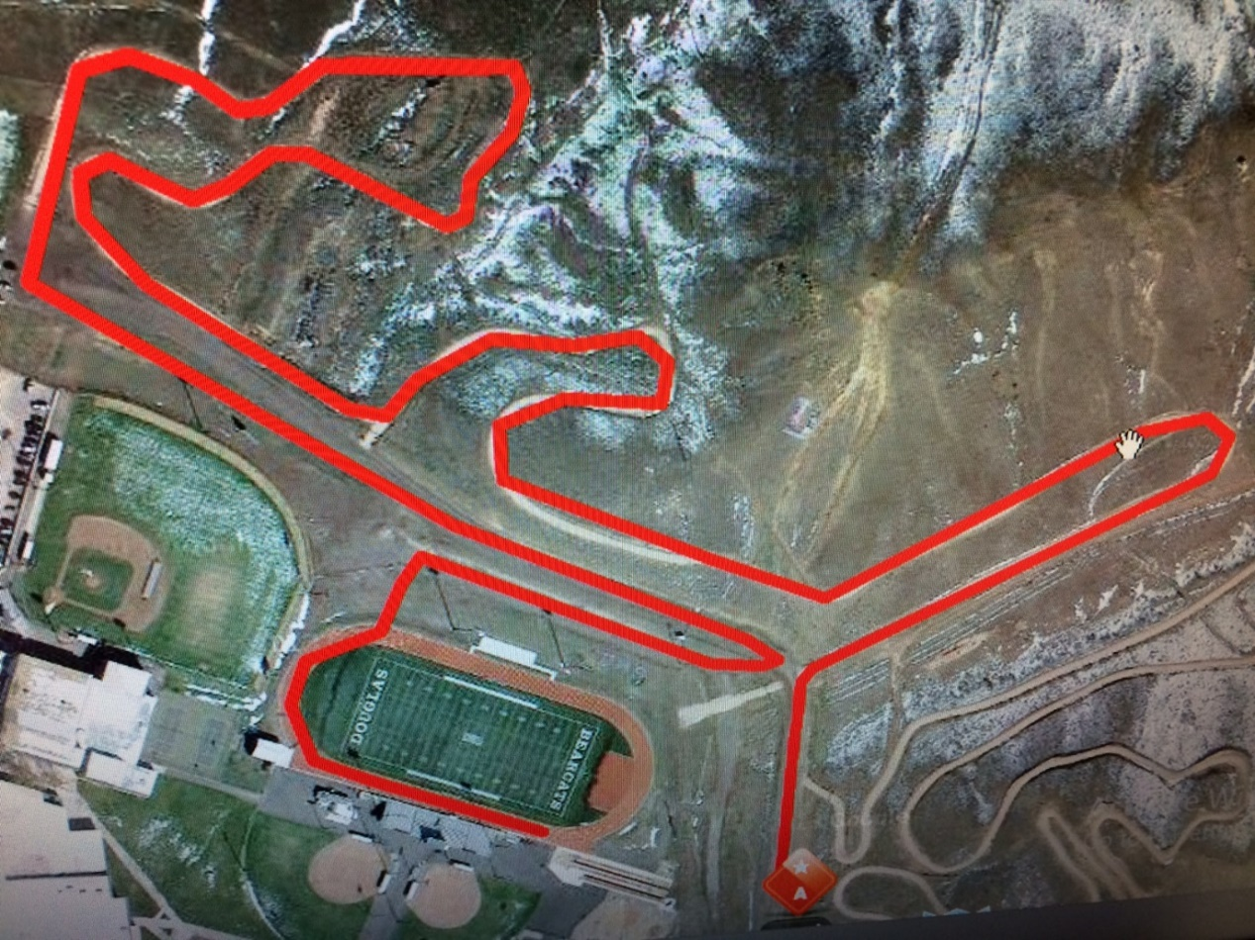
2400 Cross-Country Course

