Wayne High School
1st Annual BADGER INVITATIONAL
Thursday August 23, 2018

Cross Country Coaches,

Wayne High School would like to invite you to attend our 1st Annual Badger Invitational held on Thursday August 23rd, 2018. This meet has been approved and sanctioned by the UHSAA. The Jr. High/Middle School race will be 1.5 miles. The high school course is 3.0 miles. Both races will finish at the Wayne High School track, located behind the high school. Parking by the track is limited, so we advise that bus drivers and all fans park in the high school parking lot and walk around the school to the track.

Meet Details

Date: Thursday August 23rd, 2018

Location: Wayne High School
265 N 400 W
Bicknell, Utah
(Meet will take place at the track, located behind the high school)

Course: Runners will enjoy a beautiful, challenging course that will begin up at the Sunglow Campground, located just outside of Bicknell. The high school
athletes will be taken to the starting line by bus. The course begins on a
dirt road that shortly turns into pavement. The first 1.5 miles is mostly
downhill, except for one steep hill just before the mile mark. Right before
the road meets up with Highway 24, runners will turn onto a dirt
four-wheeler trail that follows the road into Bicknell. The trail will meet
up with 300 East in Bicknell, where runners will turn onto this road and
head up a gradual hill to 300 North. They will turn onto 300 North and
head straight down this road until it hits the track. The course will finish
on the track, with the runners doing ¾ of a lap to the finish line.

The Jr. High race will begin and finish at the track. Runners will go straight up 300 North, which is a gradual hill. They will turn onto 200 East and go down one block, where they will then turn onto 200 North. Runners will then run straight down to the track, and finish doing ¾ of a lap to the finish line.

Restrooms: Restrooms and locker rooms are available inside the high school.
We strongly advise that your athletes come dressed to run!

Time Schedule: 3:00-3:45 pm: Team check-in/packet pick up
4:00 pm: Jr. High Boys Race, Girls Race will start 5 minutes later
4:30-4:45 pm: Load bus to go up to the Sunglow Campground
5:00 pm: High School Boys Race, Girls Race will start 5 minutes
later
Awards will begin soon after the conclusion of the Girls High
School Race

Awards: Individual: Medals for 1st-10th boys and girls for ALL races

Team: Trophies for 1st Place boys and girls teams for ALL
Races

Scoring: We will be doing a 4-person scoring at this meet. The 1A
Classification in Utah has moved to a 4-person scoring as of last
year. Teams are 4-7 athletes, but each school can have as many
runners participate as they want.

Cost: $75 per school (HS and Jr. High) or $5 per runner. Please bring fee
with you on race day or mail prior to the race. There is no charge
for Region 19 schools.

Registration: Please register your team on Runnercard.com by 9:00 p.m. on
Tuesday August 21st.

Contact: If you have any questions, please contact:

Lane Sorensen, WHS XC Head Coach
Phone: 435-770-6685 (call or text)
Email: lanesorensen21@gmail.com

We look forward to having you and your athletes join us!

High School Course

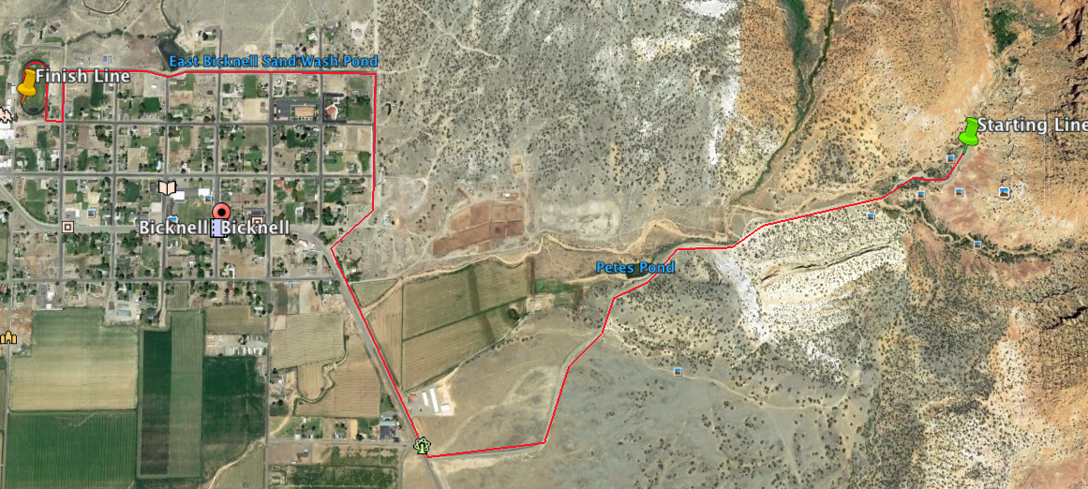

Jr. High Course

