2023 j.m. Hanks Norman Phillips Relays
Welcome to the 2023 J.M Hanks Norman Phillips Relays. This meet is being held in honor of Coach Norman “Daddy” Phillips who coached and mentored countless student-athletes and coaches in the Hanks Community starting in 1994 when he joined the Hanks staff as a retired coach after many successful years at Irvin High School. For those that didn’t know him, he was always a fan of letting Track & Field athletes have fun and try new events and build a team community. We hope this meet allows you to build on your team dynamic and connections and have some fun getting started this season with some varied events and to allow a look at individual and team event marks with less stress on division placement.
Meet entries and setup: We are running ONE Division (Open) to allow all athletes to compete in this meet and each team will be able to enter up to TWO Relays per event. Athlete names must be entered into Runnercard under each Relay. Entry limits will remain the same for all athletes with a maximum of 5 events total with no more than 3 being running events. We will have a combined team score with boys, girls, and co-ed races all being tallied for your first team to finish in the total score. Please do not enter a time or distance mark. Seeding will be random.
Entries will be due on Runnercard by Wednesday February 8, 2023 by 7:00 PM.
Running events will be made up of 4 individuals (4 Boys, 4 Girls, or Coed where specified) You will need to enter each team as A or B. (Example: Hanks Girls A or Hanks Girls B). Only your top finishing team will score in the final point total.
Field Events will be made up of 3 individuals per team. Each athlete will get 4 jumps/throws, with the exception of HJ/PV which will be run traditionally. The best mark for each individual will be added together to make the team score. Individuals will only score under the team they are listed, either A or B. In the event of No Mark for one team member the score will be added in as 0’0” to the team score but the team will still be added with the remaining two marks. If you have less than 3 individuals they can still jump/throw and we will score what is entered. Only your top finishing team will score in the final point total. Athletes need to check in at least 15 minutes prior to the start time.
Races will be timed finals if more than one heat is necessary and will be run Girls Followed by Boys with the exception of the Coed Races.
Meet Work Assignments: Please bring your own tape measure and workers.
High Jump- Hanks Pole Vault- Del Valle
Discus- Coronado Shot Put- Ysleta
Triple Jump- Hanks Long Jump- Bel Air
We will ask for everyone to help with relay exchange zones and will announce when needed for you to send a representative.
Below is the schedule of events for the meet with instructions for entries included:

FRIDAY
4:15 PM Coed 4x100/110 Shuttle Hurdles
3:00 PM High Jump
Girls followed by Boys
3:00 PM Discus
Boys followed by Girls
3:00 PM Triple Jump
Boys followed by Girls

Girl-Boy-Girl-Boy
Hurdles will be set North to South as the girls 100H and they will run extra 10 Meters and South to North as boys 110H height. Team members must wait to start until teammate has ran past the 110 M Line.

4:45 PM 4x1600
Waterfall start with exchanges in 4x400 zone.
5:30 PM 4x100 Traditional race
6:00 PM Weight man 4x100
Exchange Zones will be enforced. Must have competed at this meet in the Throwing events to run and this will be scored as well.

6:30 PM 4x400
Traditional Race.
SATURDAY
8:00 AM Pole Vault
Girls followed by Boys
8:00 AM Shot Put
Boys followed by Girls
8:00 AM Long Jump
Boys followed by Girls

9:00 AM 4x800
Traditional Race Staggered Start first runner will cut in.

9:30 AM SMR 100,100,200,400 100 and 200 runners will use the traditional 4x1 exchange zones and the 400 person will be at the anchor exchange zone for the traditional 4x400 handoff and may cut in once they have received the baton and have a clear lane to move over. Please tell your 3rd leg to stay in their lane until all anchor runners have moved on from the zone.

10:00 AM 4x200 Traditional Race and exchange zones.

10:30 AM DMR 1200,400,800,1600 Waterfall start to be exchanged at the 4x4 zone.

11:15 AM Coed 4x400
Girl-Boy-Girl-Boy Traditional Exchange zone.

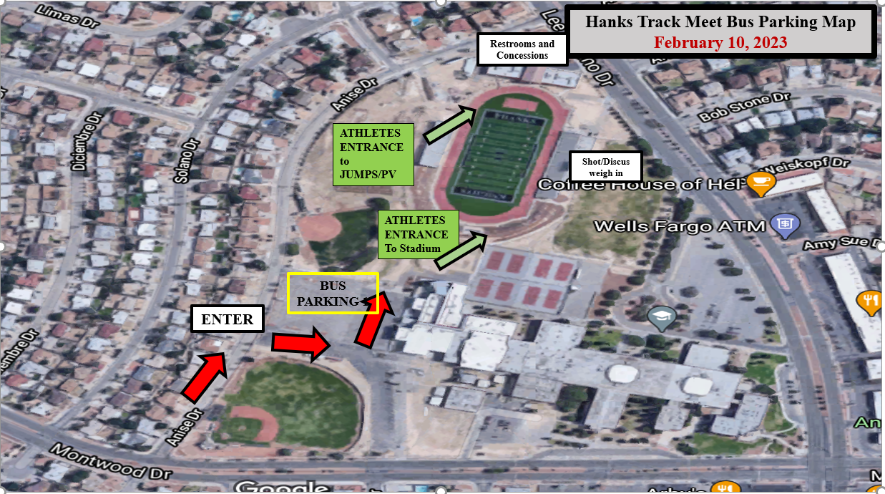

We will have a concession stand with water, Gatorade, and snacks, but please tell your athletes that it will be cash only.

We will also have coaches and worker hospitality in the press box.

Hanks High School “Norman Phillips Excalibur Relays”

High Jump-F
__________________
__________________
__________________

__________________
__________________
__________________

Long Jump-S Triple Jump-F
___________________________
___________________________
___________________________

___________________________
___________________________
___________________________

Shot Put-S Discus-F
___________________________
___________________________
___________________________

___________________________
___________________________
___________________________

Pole Vault-S
__________________
__________________
__________________

__________________
__________________
__________________

4x1600
__________________
__________________
__________________
__________________

Entry Sheets FRIDAY

Coed Hurdles
__________________
__________________
__________________
__________________

4x1600
__________________
__________________
__________________
__________________

4x100
__________________
__________________
__________________
__________________

Weight Man
__________________
__________________
__________________
__________________

4x400
__________________
__________________
__________________
__________________

Coed Hurdles
G__________________
B__________________
G__________________
B__________________

4x1600
__________________
__________________
__________________
__________________

4x100
__________________
__________________
__________________
__________________

Weight Man
__________________
__________________
__________________
__________________

4x400
__________________
__________________
__________________
__________________
Saturday

4x800
__________________
__________________
__________________
__________________

Sprint Medley
__________________
__________________
__________________
__________________

4x200
__________________
__________________
__________________
__________________

Distance Medley
__________________
__________________
__________________
__________________

4x800
__________________
__________________
__________________
__________________

Sprint Medley
100__ ________________
100__________________
200__________________
400__________________

4x200
__________________
__________________
__________________
__________________

Distance Medley
1200__________________
400__________________
800__________________
1600__________________
CO-ED 4x400
Girl__________________
Boy__________________
Girl__________________
Boy__________________

CO-ED 4x400
Girl__________________
Boy__________________
Girl__________________
Boy__________________

