TORNILLO HIGH SCHOOL
CROSS-COUNTRY
430-D Oil Mill Dr
Tornillo, Texas 79853
Athletic Director: Cody Burris

To all coaches and fans:
Welcome to another great season of exciting cross-country competition. Tornillo High School Along with San Eli High School would like to invite you and your team to the coyotes’ desert run. The meet will be held at Tornillo high school. It will take place Saturday September 21st starting promptly at 8am with a rolling schedule. Please be aware of the early start time and directions to get here.

REGISTRATION: Will be done entirely through www.runnercard.com

Order of competitions:
ELITE Girls (7 runners per team)
ELITE Boys (7 runners per team)
Open Girls (unlimited)
Open Boys (unlimited)

Distance: BOYS 5k, GIRLS 2 Miles

Course: Race will consist of the start inside the football field and head out around the campuses using dirt roads, ditches and arroyos.

Awards: Medals will be awarded to the top 10 individual finishers
1st place teams will get a trophy

Misc: (parking) there will be designated parking to make race more spectator friendly
(Registration)Through runnercard
(Water) Coolers will be available in the field
(Restrooms) Will be available next to the concession stand
(Concession) Will be available in the field house
(TRAINER) PLEASE NOTE WE HAVE NO TRAINER OR SUPPLIES ON SITE, PLEASE BRING YOUR OWN.

Contact: Jesse Garcia Head coach 256-1204 GarciaJ@tisd.us
Cody Burris Athletic Dir. 491-1009 BurrisC@tisd.us
Adrian Guerrero Assit. Coach 490-0432 GuerreroA@tisd.us

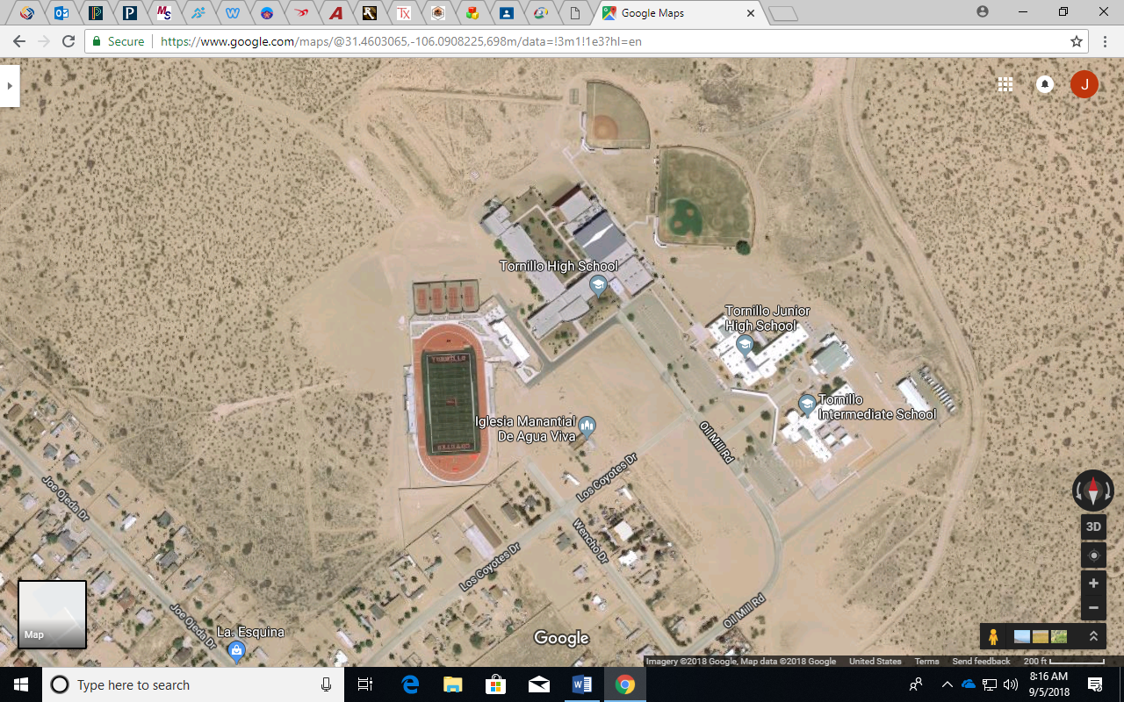
2miles finish start

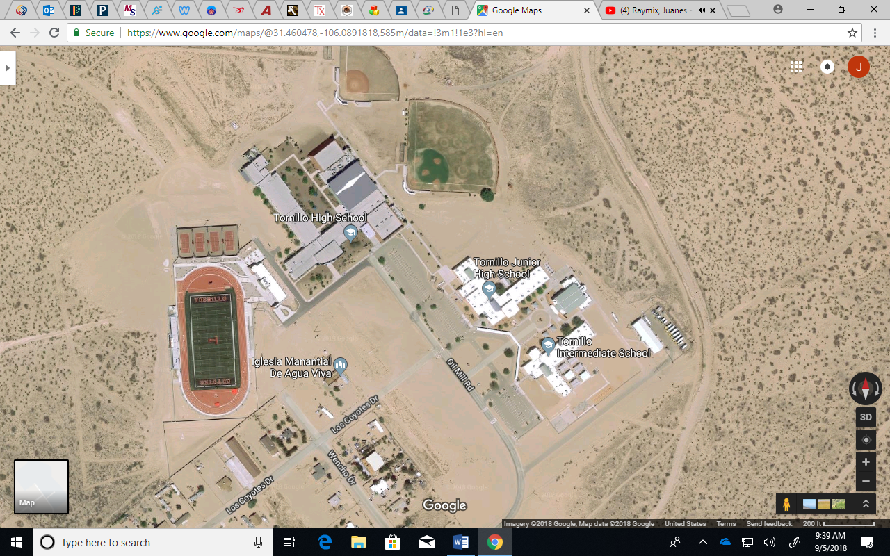
5K RED = 1st loop BLACK = 2nd loop

