

2019 GISD Middle School Cross Country Invitational

The Gadsden Independent School District would like to welcome you to our GISD Middle School XC Invitational.

Date: Tuesday, September 24, 2019

CC Meet Host: Chaparral Middle School
Chaparral, NM 88081

Coaches Meeting: 3:30 p.m.

Race Time: 4:00 p.m.

Order of Events: 7th Grade Girls
7th Grade Boys
8th Grade Girls
8th Grade Boys

Course: Flat course (grass, pavement and dirt).

Awards: Medals - Top Ten for Boys and Girls (all races).

Trophies - First Place for Girls & Boys

Chaparral Middle School concession stand available for snacks and refreshments.

If you have any questions, please call do not hesitate to make contact.

Karen Nougues
GISD Athletic Director

Cell Phone: (575) 644-3958

Email: knougues@gisd.k12.nm.us

GISD XC Invitational Course Map
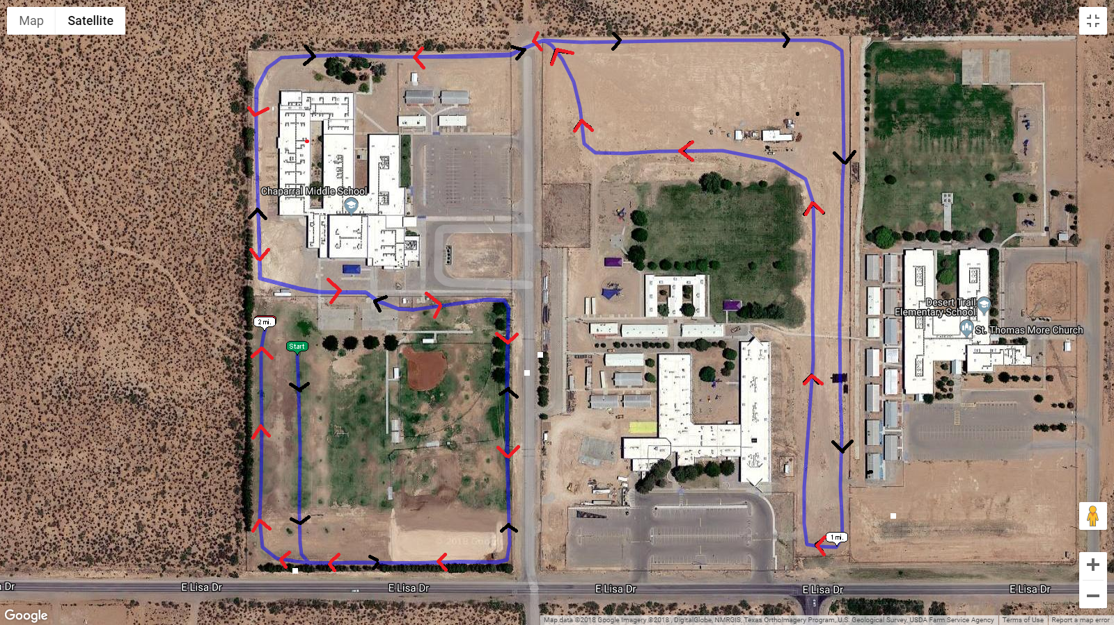
Chaparral Middle School

