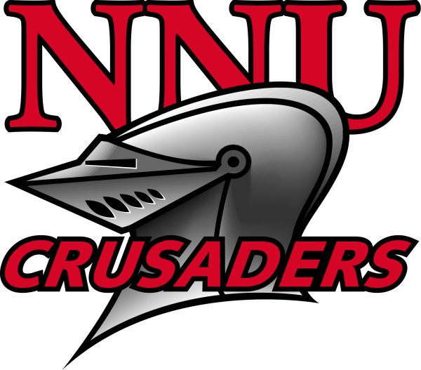
Northwest Nazarene University
Invitational Track and Field Meet
Saturday April 8, 2006

Field Events
10:30 a.m. Hammer Men (Women to follow)
Pole Vault Men (Women to follow)
High Jump Women (Men to follow)
Triple Jump Men (Long Jump to follow) SW Pit
Triple Jump Women (Long Jump to follow) SE Pit
Shot Put Women (Men to follow)

1:30 pm Discus Men (Women to follow)

FRIDAY NIGHT April 8th Women’s Javelin (men to follow) 4:00 p.m.
Men and Women’s 10K 5:00 p.m.

Throwing events Top 8 to finals.
Check-in at Field Events 20 minutes prior to start.

Running Events (Women first then Men)

12:00 400m Relay
12:10 1500m
12:30 100H
12:40 110H
12:55 400m
1:10 100m
1:25 800
1:45 400H
2:05 200m
2:30 Women’s 3K
2:50 Men’s 5K
3:20 1600 m Relay

Check-in to running events at starting line 10 min. before race.

Northwest Nazarene University
Invitational Track and Field Meet
Saturday April 8, 2006

Entry Information: Entries are due at www.runnercard.com on Wednesday April 5th at 5:00 pm for all events. Entry fee is $50.00 per gender or $100 per combined team. A receipt will be available in your meet entry packet. Packets will be available at the finish line building beginning at 9:00 am.

Scratches: Field event scratches will be made at the event. Changes in flights and order may be adjusted to provide equal competitive opportunities for all. Running event scratches will be made at the finish line building beginning at 9:00 am. Heats and lane assignment may be adjusted prior to the start of the meet.

Check-in: Field event check-in will take place at the event. Running events will check-in at the starting line of the event 10 minutes before race time.

Trainers: Certified athletic trainers will be available before and during the meet. Ice will also be available during and after the meet. Additional needs can be provided by contacting Ken Becker at 208 467-8344.

Implement Weight-in: Will take place at the finish line building between 9:00 and 9:45. All implements will need to be checked in at this time. Implements will be brought to the throwing area in time for warm-ups. Illegal implements will be impounded until after completion of that event.

Showers: Locker room will be available before and after the meet. Please provide your own towel.

Scoring: This meet will not be scored.

For more information contact:
John Spatz
208 467-8247 Office
208 989-9445 Cell
(jtspatz@nnu.edu)

