2020 Laramie High Plains Showdown
Friday, Sept. 25, 2020

-----------------------------------------------------------------------------------------------------------------------------------------------
SITE: Jacoby Ridge Trail, located at the very east end of Willett St. (Take Willett St. east past the Jacoby Golf Course and past the hospital). The road ends at a cul-de-sac. Fans and spectators may need to park up the hill as the lower portion will be reserved for buses.

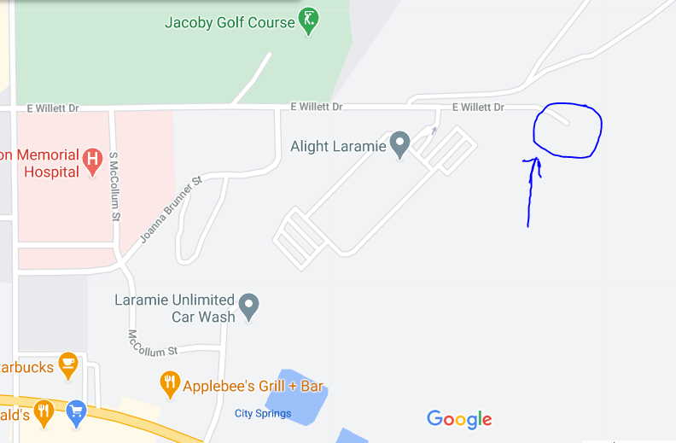
Race Starting area on map above

Registration must be completed by noon on Sept. 24, 2020. Please contact the race director with any changes after that time. Registration must be completed on RunnerCard.com.

Course: The course will follow a 2.3-mile loop (gravel path) known as the Jacoby Ridge trail with a small loop addition (about .6 miles) that will consist of dirt and sand. Spikes are not advised to be used. Please bring plenty of water and be aware shade is not available.

Order of races and approximate starting times:

9:00AM Open Race-boys’ start, 9:05AM Open Race-girls’ start

10:00 AM First Race-Girls’ Varsity (Seven athletes max per team)
10:30 AM Second Race-Boys’ Varsity (Seven athletes max per team)
11:00 AM Third Race-Girls’ JV (Seven athletes max per team)
11:45 AM Fourth Race-Boys’ JV (Seven athletes max per team)

Teams attending: Cheyenne Central, Cheyenne East, Cheyenne South, Laramie (any team withdrawing or with smaller numbers may allow the addition of another team) Please register ASAP

Special Instructions for athletes: Please keep masks on while not running and on start line until the start of the race. Please respect others and maintain social distancing while stretching or cheering on athletes. Mask must be worn immediately following the race.

Athletes/Coaches: Athletes need to have the number listed next to their name written on your left shoulder with a Sharpie. These numbers will be used to track finish results. Your race number will be provided in the team packet.

Portable Restrooms will be available

No awards will be presented and results will be posted on RunnerCard.com following the final race.

