2018 Douglas Middle School
River Run
Friday, September 14
Douglas Middle School River Trail
Douglas, WY
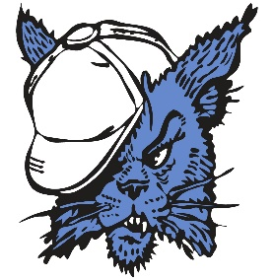

*** Please make sure you enter all athletes on RunnerCard before 7:00 pm on Wednesday, September 12th. ***
2:00 - Course opens for walk through and warm-up
3:30 - 6th & 7th Girls Race
4:00 - 6th & 7th Boys Race
4:30 - 8th Girls Race
5:00 - 8th Boys Race
***As soon as one race finishes, the next race will begin. Races may run ahead of schedule.***
Water and Popsicles: Athletes will have access to water and popsicles near the finish line.
Stickers: We will be using stickers at the finish line for placing. Coaches will receive their stickers in their coaching packet. Please make sure the following information is on each sticker: Student name (first and last), school, and grade level. All stickers must be placed on the chest of the competitors.
Parking: Buses will need to park in the new parking lot East of the fields behind DMS. Look for signs marking the bus entrance. Overflow bus parking will be available after 4:00 pm in the South Bus Loop located in front of Douglas Middle School. All spectators may park in the back parking lot behind DMS. Overflow spectator parking can be found in the front parking lot of DMS.
Course Markings: The majority of the course will be ran on the jogging path along the North Platte River and marked with flags. Standard yellow, red, and blue flags will be used throughout as well. Course judges will be stationed along the course to handle any emergencies. A Gator will lead each race to ensure the runners follow the appropriate route.
Restrooms: Restroom facilities will be available during the meet, and are located behind the first base line of the softball field near the school. Locker rooms will not be available and coaches/athletes are responsible for their team/personal belongings.
Awards: Shirts will be awarded to the top five finishers of each race listed above.
Entry Fee: None.
Results: Results will be available on RunnerCard following the meet.
We look forward to seeing all of you on Friday the 15th. If you have any additional questions, please contact the Activities Office at (307)358-4040 or Coach Emily Haught at (307)358-9771.

2018 DMS River Run Cross Country Meet
Course Map

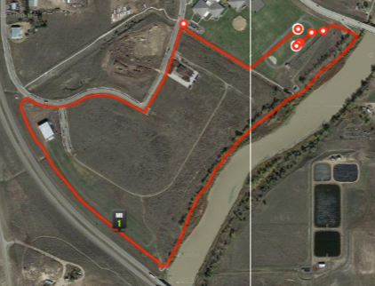

The starting line is the upper bullseye, and the finish line is the lower bullseye.

